**C# Based Tutoring System Using Cloud Computing**

Final report

Submitted for the BSc(Hons) in

Computer Science

April 2020

by

Harry Agyemang

Word count: 13,566

Abstract

This paper describes a C# tutorial system to teach programming, in this case, for the language C#. This paper introduces C# to students using a tutoring system that looks at the first twenty hours because it covers the primary material a student would need to learn. Students would need the most help and support during this teaching period. This paper introduces a remedial function that looks to influence the first twenty hours of the learning experience, ideally aimed for first-year Computer science students. The revision material is on The C# language, and students go through the lesson with interactive features and examples to help them understand the topic. The paper will discuss a version control system for students to upload code learnt from using the tutorial and collaborate with students on projects. The background will cover looking at existing models and the approaches of teaching programming to students. The evidence collected is from tutorial systems already out there which teach learners programming, and this project will explore the styles used to show it whether it's through interaction, animation or getting the student to complete quizzes. Using a tutorial system is efficient in guiding students through the learning process. The software will produce a series of prototypes, starting with designing the interface of the tutor. The conclusion at the end will indicate whether using version control support and enhance their learning experience through the uses of the C# tutor. This project will end with a detailed evaluation of the system, reflection on lessons learnt and suggestions for future work follows.

Acknowledgements

In this project, the first thanks are the project's supervisor Dr Mike Brayshaw for his continued support and guidance throughout this dissertation.

Contents

Introduction 3

1.1 Background to the project 3

1.2 AI on Learning experience 3

1.3 The C# tutorial system 4

1.4 Aims and objectives 4

1.5 Research question 5

2 Literature review 6

3 Requirements 13

3.1 Product requirements 13

3.2 Functional requirements 14

3.2.1 Interfaces 14

3.2.2 Remedial 19

3.2.3 Learning Experience 21

3.2.4 Educational Data Mining 22

3.2.5 Constraints and Limitations 23

3.3 Design constraints 23

Design 23

3.4 Version Control System 23

3.5 The C# architecture 24

3.6 Iterative and Prototype Design 27

3.7 C# tutorial- Sketches 27

3.8 C# tutorial- Windows Forms 31

3.9 Computer gaming and Human-computer interaction 36

4 Implementation 37

4.1 Final Designs 37

4.2 Test cases 40

5 Evaluation 45

6 Conclusion 48

7 References 51

# Introduction

This project will explore tutorial systems and cloud computing with the primary objective of teaching students C# integrated with the version control system. Learners will use GitHub, a cloud base support system, to further their coding abilities and assist them in a future career in Computer science. The purpose of this tutorial system is to educate students on C# by teaching the first twenty hours of the material. It is important because the scope covers the required basic programming concepts students must know to move onto the advanced topics. The project will discover effective teaching techniques, cloud computing and intelligent tutorial systems. Understanding the importance of this system can help move away from traditional classrooms to an online platform. This system acts as a teacher and thus gives the student a new experience of online interactive classes to simulate learning. The main objective being to help students progress, e.g. if a student is struggling, this tutoring system will be a perfect alternative for assisting them.

## Background to the project

The stakeholders interested in this project are universities and other businesses that work with learning and tutoring, for example, Kumon (Kumon UK, n.d.). Every student using the tutorial system will go through five sections and at the end of each chapter there will be a module quiz.

Intelligent tutorial systems are the future and maybe the way forward. The current pandemic of Covid-19 is an example in which businesses are moving their operations online. Employees can work from home instead of being in an office environment to work. In this situation, it would be beneficial for a tutorial system to be effective in terms of learning C#. universities have move lectures online as an alternative to teaching students. This shouldn't affect students from using version control systems such as GitHub as they are still able to upload code and work in teams on projects from the comfort of their own homes.

These online courses can be designed for students and be made accessible with a wide variety. They can contain the whole curriculum and teachers can provide material for students to access. Students would benefit from an online environment where they can have unlimited access to course material and the ability to work and collaborate with other students at any time of the day. (Stanford, n.d.)

**An initial overview of the content**

There is a belief that an online tutorial can enhance the experience by providing a significant interaction and more directed guidance than a book. Its goal is to ensure the tutorials offer a personalised learning experience. The main aim is to try and ease the transition of a novice towards understanding the basics of programming and using what they have learnt to be able to apply these ideas effectively.

## AI on Learning experience

AI tutorial systems perform tasks like grading that can help students improve their learning and even substance tutorial systems. Its tools can help students to ask questions and find out information and take the place of a teacher on course material. AI is changing education delivery in terms of the learning process and how it's taught. Adding effective use of personalised learning and providing feedback on areas of student's strengths and improvements to ensure long term success for the future of their career. These systems respond to the needs of students, by emphasising topics, repeating things that students haven't mastered and work at their own pace. Various tutoring programs, learning applications and skill-based exercises developed to make it more AI-based. This AI-enabled system will transform classrooms into an online platform. (Arora, 2016)

## The C# tutorial system

The tutorial system will use content from the C# yellow book for each section and at the end will ask a series of questions to do with it. This remedial function implemented in the system. If the user gets a question correct, they move onto the next question. If a question is answered incorrectly the user can continue but the result must be above 60% to move onto the next section.

The only changes to this project were the original plan of using inquiry-based learning to teach students C#. It will include having simulated data on students , for example, "Harry1", "Harry2" and "Harry3". The tutoring system consists of four types of questions, e.g. Radio button, Checkboxes, fill in the gap and drag and drop.

## Aims and objectives

**Aims**

- To increase student engagement in the learning process, e.g. having a greater understanding of the C# programming language.

- To serve a diverse range of students, which reduces barriers students face as to respond to their unique learning needs.

- To provide students with a safe and comfortable learning environment (OTC Speckman Tutoring and Learning Center, n.d).

- Ensure students using the tutorial system can write programs.

- Implement a teaching strategy in the tutorial system.

- Aim to teach the first 20 hours of programming.

**Primary Objectives**

- Create/ design the interface of the tutorial system.

- Add ability for users to login with username and password and tailor the response of the system.

- Develop a feedback mechanism for the student.

- Use a range of different Multiple-choice type questions to engage the student in the tutorial system.

- Use a method of teaching for the tutorial system content. Each lesson is broken down into sections for the user to understand.

**Secondary Objectives**

- Logging systems recognise student usernames and passwords

- Context on C# is correct and up to date using C# yellow book the latest edition. (Miles R, 2011)

- Input a remedial function for the module quiz.

- The idea to promote critical thinking and setting objectives for the students to understand the concepts of C#.

- Introduce the student to version control GitHub.

- Students will learn how to write programs.

## Research question

Modern Software Engineering uses Context Cloud-Based support and version control. The uses of cloud base are to increase capacity, enhance functionality and even add additional services on demand. Cloud-Based support offers an alternative way to not spending money on infrastructure and being able to train and support staff (Beal, n.d) Computer language is cloud-based, and It is appropriate to train people within this context.

**The question for the project is**

How can a cloud compute support student learning by using a tutoring system?

# Literature review

This chapter will provide background material and themes of relevant tutoring systems and the authors. Giving us an insight into how the systems function and these all relate to this project in using a tutoring system for learning purposes and letting students realise their full potential.

There has been a recent development in computer-based systems that display a degree of intelligent. The purpose was to capture the knowledge that allows experts to compose an instructional interaction. The teaching technique of intelligent tutoring is different from human teachers. Even though the computer is not very good with improvisation, they tend to outperform people in the precision and completeness with the available information. These systems can interact with the human to communicate knowledge, recalling relevant information, explaining difficult areas in more depth.

**Intelligent systems**

The tutoring systems will involve the assumed principles but keep the same core structure; for example, the learning experience and benefits. Also, it will help boost confidence as students will trust their ability to learn and be in control of their learning. The system can help students have a better feeling as the system will make students feel confident and relaxed.

Cognitive computing is an emerging field with involvements of computer technologies. Behind it is the scientific theories which provide a framework in describing models of human cognition; this includes how information is represented and processed by the brain. Data science offers a processes’ system which extracts knowledge from both structured and unstructured data. Cognitive computing involves computing discipline theories, methods and tools for the modelling of human cognition. The recent improvements in computing disciplines, machine learning and cloud computing are helping cognitive science and cognitive computing. (Gudivada, 2016)

This system requires artificial intelligence techniques which are in four interacting components: namely knowledge base, student model, pedagogical and user interface. With a knowledge base, this can have a diverse approach in the method of teaching it. This system highlights the importance of bringing Intelligent tutoring systems into schools to explain certain aspects of a module. The pedagogical model which contains suitable instructional measures that are contingent with the student model.' (Gudivada, 2016; Smelser and Baltes, 2001) For example, Anderson et al. (1995) introduced the ACT cognitive architecture and developed it into an advanced computer tutoring theory. There were three ACT-based production models in which Anderson developed. The modules would reflect on how students solve problems in maths topics. From the results, the students were able to achieve the same level of performance which the cognitive tutors compared to the conventional.

An experiment was carried out with the LISP tutor monitoring the learning of 500 productions which describe the programming skills (Anderson, Conrad and Corbett, 1989). Productions tries to model a human tutor using computer-based rules, and those rules are 500 productions if or else rule. They follow a power-law learning curve, transferring programming experiences and extending them. Remediation, the content of feedback and timing of feedback are beneficial to the student as it gives them more practice programming and explains to them why the solution was correct and provides long term learning benefits. The ACT programming helps students to complete programming exercises. The tutor system is constructed from the ideal student model. As the student completes each exercise, the tutor will give an estimated probability that the student has learnt each rule. The student model helps tailor the learning environment to students, enabling them to reach high levels of understanding and increased performance.

ACT is an environment for students learning to program; this contains exercises that require the student to read and write programs and monitor the student's behaviour on a symbol- by symbol basis. The program has Lisps and Prolog modules which teach a self-paced introduction to the system. How it works is students will enter code one symbol at a time, either typing it or through the menu (Corbett and Anderson, 1993). Koedinger et al., (1997) based his research on the ACT cognitive architecture. Koedinger conducted an experiment on 470 students, the results showed that students in these classes outperformed students in categories who did standardized tests. Aleven and Koedinger support guided learning using cognitive tutoring. This is because students who explained their steps during a problem-solving practice had a greater understanding compared to the students who did not disclose their actions. (sciencedirect, n.d.)

**Student model**

This model focuses on learning content knowledge, student's perception and the experience of programming. The student model provides students with theory to read, then examples of how it is being used and finally programming exercises. The student model is one of four major components in the architecture of intelligent tutoring systems. The tutor model relies on the knowledge provided by the student model to adjust its intelligence to provide immediate feedback and individualised the tutoring system for the student. The second student model solves a wide range of research questions (Gong, 2014).Students can see what they got right or wrong, based on their answers the tutorial system can then be changed e.g. in a Maths tutor if the student got addition, subtraction and multiplication right, but they got division wrong the system would concentrate on division because as there is evidence to prove this.

**GitHub and cloud computing**

The version control system saves revisions and stores the modifications in the repository. It can be useful for students when collaborating on a project as they can download new versions of the software, make changes to it and upload the new revisions. The tutorial system will consider GitHub because it uses services, including access controls and keeps track of constant revisions to their code. The tutor system provides an opportunity for students to create a profile and transfer their skills learnt from the C# tutorial system to GitHub. Using this hub creates a community in reviewing, improving and deriving new ideas from uploading code. Students who use the tutoring system, will then go onto develop skills in creating applications and working with different people. For example, students looking for graduate roles would attach their GitHub account to their portfolio, showing evidence of practices this will increase their higher chance of being recruited in a job such as a software engineer. This tutoring system provides students with the opportunity to create a profile and transfer the skills they have learnt from C# onto GitHub (Apiumhub, 2017).

An intelligent tutoring system for cloud computing aims to provide immediate reactions to leaders without the intervention of human teachers. Cognitive learning and design theories all contribute to ways of improving the effectiveness of a tutoring system. Using cloud computing systems to teach student general concepts and component of computer programming. (Hasanein and Abu-Naser, 2017)

**Version Control**

The tutorial system will use GitHub as it is reliable, easy to use and can handle small and large applications**.** Without it, working in groups would be more challenging as groups would overwrite code changes that someone else may have completed. It is also good at keeping track of application builds identifying which version is currently in development (Segue Technologies, 2013).

For a single user, the advantages of using GitHub is for its automatic backups. For example, if the user accidentally deleted some files the version control system backs up work while working on a piece of code. The version control system has a branching mechanism, this means if a user had a section of code with errors within it, they would only need to fix the mistakes, and the version control will merge the code to the other versions. All the changes in the code are tracked and can be reverted. Another reason to use version control is restoring previous versions. Being able to restore old files means if the changes were not up to standard, then the user can simply undo them. Every time the user saves a new version, it requires the user to provide a short description of what has changed (Git-tower.com, 2013).

GitHub offers its users a cloud-based git repository hosting service. This makes it easier for students and groups of coders to use GitHub for version control and collaborate with eachother. (Jackson, 2018)

**Virtual learning environment**

The paper involves intelligent tutoring systems in a virtual learning centre. It affects the teacher's decision-making in a virtual classroom environment. The VLE provides an environment for each student by having more practical based multimedia case and enabling them to communicate with their peers and teachers. This system creates an environment that is designed to facilitate teacher's management. It aims to complement the efforts of teachers and integrate technology into their classroom and provide students with a positive and enjoyable environment to study. The Benefits of VLE are to improve the quality and effectiveness of the causes and to have a teaching process with interactive features, aiming to deliver a more personalised learning experience to students best suited for the individual learning styles. Lastly, promoting critical thinking and analytical skills by developing self-learning skills through these uses of the tutoring system (Kumar Pagadala, (2015).

**Gaming and motivation**

In this paper, it discusses how using source control can provide a learning technology to measure and encourage learner's engagement. For instance, how games motivate players and how they can emulate that in learning and teaching. The research uses a case study from source control logs from a laboratory task. The system then illustrates a method to measure student engagement with lab activities across a module. The results came from student's participating during self-directed learning activities using source control.

The overall goal is to use technology to develop a system to increase motivation and engagement, using game design principles. Source control is a fundamental and valuable professional skill for a programmer. When learning a new concept; it eliminates the risk associated with experimentation when students are programming. For example, knowing that previous versions are available and that there is less impact if the student breaks the code, giving the freedom to experiment and learn. Students can submit working code to a repository which allows the freedom to investigate new concepts knowing that their work files are easily retrieved. Lab work for this module includes a series of checkpoints. The student working on a project checks their work into version control whenever they make progress. By examining the data and log message for students committing, this is used to measure engagement used in the task set within the labs. The labs would give the student more flexibility to work at a time which is best suited for them.

Critical information is found in the SVN logs. For example, by observing the SVN data from the labs, lecturers can see how much of the lab has been completed and how long students spent to complete each task. Students who are behind on work or taken longer times to complete it can indicate they are struggling with the work or have not had the time to complete it. Lastly, this information displays students who check-in times outside of labs which shows they are working outside of lab hours. (Grey, 2014)

Self-motivation Theory represents the study of human motivation and personality this is based on a intrinsic and extrinsic motivation in cognitive and social development. It has effects on social and cultural factors and impacts people's sense of volition and initiatives in addition to their wellbeing and the quality of their performance. (Selfdeterminationtheory, 2014) For example, in Glued to games, it focuses on the satisfactions and consequences of video games. This paper outlines the primary motivational language for many gaming psychologies. The research came from parents who are trying to decide how to regulate gaming for research. It involves developers who are making the games and policymakers who are tackling issues such as violence and addiction. Developers want to find out about the self-motivation theory, so they can build it into their games. Developers wanted to know this to identify these properties and put these into whatever they are developing.

(Rigby and Ryan, 2011) argue that the correct theory of motivation should not focus on behavioural classifications by the structure of games but address the factors which are associated with enjoyment and perseverance across players and genres. Also, how games differ in controllability, structure and content, this might appeal to human motivational propensities and psychological needs.

SDT can be used to investigate both players' motivation to play games and the factors that may motivate a players' character. This predicts that game features increase perceptions of autonomy, competence and relatedness enhance motivation to play (Ryan, Rigby and Przybylski, 2011). This article gives a brief overview of SDT as applied to educational practices. Both intrinsic motivation and autonomous types of extrinsic motivation has positive effects on students' academic outcomes. There are strategies for enhancing autonomy, for example, providing choice and meaningful rationales for learning activities minimizing pressure and control. (Niemiec and Ryan, 2009) This paper uses gamification to understand the motivational benefits of applying the self-determination theory in adaptive social e-learning. E-learning requires a mechanism to assist students in directing their learning and having high levels of motivation to participate in meaningful interactions. For example, to fulfil the autonomy need, a set of learning goals with clear description and multiple paths must be achieved. To meet the competence needs, they suggested providing direct and positive feedback, optimal challenges and freedom of evaluation. Various ways of social interactions can support relatedness, for example, tagging, rating and commenting and sharing with a learning community. (Shi and Cristea, 2016)

**Feedback mechanism**

It is necessary to integrate feedback into intelligent tutoring systems as it is essential to consider both the individual needs and requirements. The intelligent tutoring system makes learning material more flexible and is modified for a more educational approach for the student. The research aims are to find out what is essential for successful learning and the impact of the feedback mechanism. Feedback aims to assist learners in knowing what they got wrong and the solution behind it, becoming aware of their misconception and reconstructing their knowledge. Another is to help learners achieve underlying learning goals. The feedback mechanism should adapt to learner's individual needs. Lastly, help learners to determine performance expectations, with identifying what they have learnt and what they can do to help their learning progress.

The feedback mechanisms in the ITS allows receiving feedback after the student has completed the test, which has benefits of gaining confidence in mastering the subject. The feedback mechanism can help learners to understand the task in a more profound and in-depth way. The student must learn to improve their knowledge with feedback using the cognition processes and to motivate their learning. (Dāboliņš and Grundspeņķis, 2013)

Soloway (1986) discusses teaching practical problem-solving skills in the content of teaching programming. He states students should be given explicit instructions and explanations to deal with problems within a programming exercise. For instance, Soloway changes the curriculum to enable students to transfer what they have learnt from programming exercises to other problem-solving situations. Programming will be established as not just a vocational skill but for practical problem-solving in a tutoring system. (Soloway, 1986)

In a traditional intelligent tutoring system by using formalized domain knowledge and dynamic system model, they can compare student's problem-solving steps to domain models. It is possible to adapt instructions to the student's specific needs and defectively support their learning. These models inferred by machine learning constitutes technology to gather meaningful information from the examples. This is about the domain in term of educational data set, for example, solution attempts made by students or samples from experts on how to solve the problem. provide meaningful automated feedback with machine learning methods; input data must be a key factor. (Gross et al., 2015)

Corbet & Anderson(1985) have been using immediate feedback for tutorial systems and mathematics tutors. For example, they use ACT programming tutor to examine different timing effects on students' learning. The system involves four feedback conditions; the first three offered the student different levels of control over error feedback and correction. (a) as soon as the student made errors, it focuses on correcting the mistakes before moving on. (b) immediate error flagging and the student control of error correction. (c) feedback on the demand and student control of error correction. (d) no tutor condition and no step by step problem-solving support. The results showed that these students completed the tutor problems fast and had an excellent performance on the test, proving that immediate feedback helped with student learning (Anderson, Corbett, Koedinger, & Pelletier, 1985)

Feedback must be responsive as it is an essential component in the learning process. There has been research on proving learning efficiency increases when immediate feedback for the student is given . Van Merrienboer and Paas, (1990) discusses a fill in the gap method used for programming. This test student's ability to find solutions in missing text/ code and gives feedback on whether they were correct or not correct but directs them to the section they need to revisit to understand it better. For this type of question, the code in the exercise is on general concepts with additional missing code. The student would need to understand the code to complete the training. They incorporate the knowledge learnt from the section to be used on the exercise and find solutions. Thus, proving that the fill in the gap programming exercise has helped close the gap between existing knowledge and new knowledge gained. (Van Merrienboer and Paas, 1990)

**Question type - Fill in the gap**

Filling in the gap has the effects of reducing the complexity of writing code. Programmers struggle with their program because they are not used to thinking abstractly, they need a partial solution to the programming problem, which would give them a better understanding and increase their chance of getting it correct.

For example, a current system which uses this is the ELP which provides a web base fill in the gap exercise. Students can use the tutoring system at their own pace. The ELP is a web-based programming environment which supports the following languages; Java, C# and C. From this, the student can complete the training and submit their answer. The system can give positive or negative feedback, significant in the role of the students learning process. Also, the dynamic analysis framework can analyse the fill in the gap. This structure uses the client-server to where the student's program takes place, It consists of black testing and white box. Black box testing sets a filter, normalisers and matches to compare the output of the student's gap solutions, with a model solution. The white box has support from two types of the harness: a default test and a customised one for the teacher. (Truong, 2005)

**Existing tutorial systems**

The CBT C# tutorial for beginners by Lloyd Galador (Dupont, 2009) is divided into four tutorials, one after the other. It is a set of programming exercises that requires the student to copy the code and run it on the command line. The tutorial system contains aspects which help motivate the student by giving feedback when they get a question correct. The system encourages the student to develop and build confidence when using the tutoring system as they feel like they have achieved the task and are doing the right things.

Devhood C# Tutorial (Chiu et al., 2001) is an example of a CBT. The tutorial system consists of an indexed document, which contains exercises and source code. However, this is for more advanced learners who are familiar with programming languages already. This is because the code presented is not explaining the aspects in much detail.

The C# Station Tutorial (Mayo, 2009) is web-based tutoring system that is separated into 23 lessons. Within these lessons, they contain information on the topic, source code and the ability to click a button and run the code to find out the output. Navigation is easy as it has links from other lesson to the first lesson. The tutorial starts teaching users from the command line before it moves them onto C# basic concepts. It contains a mix of explanation, text and programming code, also an open-source where students can execute code with things that help cater to all abilities. Users can build up points once they get a question right.

Paradise.com (Singh, 2008) is a tutoring system which has a personal tutor that teach the student programming using a voice chat, there is also a whole board shared between both student and admin for practical demonstrations on the student's computer. This method of teaching is unique compared to the traditional and other tutoring systems already out there. Carrying out lessons and getting an instant response in feedback. The tutor and the student would need to be available at the same time for studies. This system detects when a student did not fully understand the task and comes with exercises and examples to help achieve clarity.

An example of a Computer-based tutorial is joe grips tutorial which has an animated interactive tutorial. Interactive Words & Pictures (2008). In this tutor talks to students explaining in detail about the programming code and can visually highlight sections. As it runs through the total, it also asks students to complete a range of programming tasks, giving them a hands-on learning experience becoming active learners. It requires students to listen and view the screen to learn and pick up key information actively. One recommendation is to input a tool which can see how students are progressing through the tutoring system. This tutoring system would require students to be taking notes while learning, so they have information to refer to when doing the programming task.

A C# tutorial system must use a range of positive and motivational language when using it because it makes the systems more user friendly and encourages students to build confidence and trust their ability. (Friedman and Felleisen, 1987)

In the content of teaching computer science, this builds upon the learning activities established by (Gordon and Brayshaw, 2008, 2009). They used a way to embrace the method of control and learning philosophy, used to teaching computer science. This paper mentions what it is like to learn and teach in such an environment. There was an experiment done, and all the students completed the single mandatory projects. All students manage to receive in-depth personal attention from the staff members. This activity showed students achieved a better score than expected compared to the conventional summer school. This paper considers an approach to support students of computer science in their studies. The reassertion of studying computer science can be challenging for many students and teachers. One issue is a wide variety of students from different backgrounds varying from no experience to extensive development practices. Improving these outcomes of introducing programming is to identify effective ways of improving student engagement and the user development in their ability to program. Computer science is a discipline that includes both theory and applications; the ability to carry out a form through programming means the student must be able to translate the theory and skills that they have learnt into actual practices. The aim is to develop student computational thinking (Eisenstadt, et al., 1996)

Through motivational activities; it has the potential to improve student engagement in their studies. Discovery learning allows learners to find their explanation and solutions. The framework for teaching programming includes Student interface, source control, tutor services, and tutor interface. Various aspects have been implemented for example, the use of source control to identify student behaviours and track their difficulties. The aim is to improve student engagement with the consequences of promoting the development of computational thinking. It offers a flexible structure to enable students to learn at their own pace and style. This approach uses both pedagogy and technological framework with the involvement of source control and engaging, interactive interface. (Gordon, et al., 2019)

# Requirements

In this section will be a description of the needs of the software. It will include features, function and any critical aspect. The requirements proposed are to ensure the software is up to standard and does what it is supposed to do.

- To analyse feedback mechanisms in previous systems

- Implement different methods of teaching programming language

- Develop an interface which enhances user engagement with a tutorial system

- Teach students version control and how they can use it to showcase their skill

- Implement a teaching method which is best suited for students.

## Product requirements

The tutorial system is broken down into sections and at the end of this student will have to complete a module quiz and achieve a pass rate of 60% to move on. Here are some example of product requirements for the user.

**Examples**:

- Function- As a student, he/she must be able to read and understand content to complete the multiple-choice questions at the end.

- Features- The tutorial system will have a fill in the gap to find the missing word/code for the multiple-choice questions.

- Performance- The system must be able to run smoothly without errors. But if an error occurs, then it must direct users back to a safe environment on the network, e.g. the dashboard.

- Operation requirements- The tutorial system responds to students with message weather they have got the question correct as to form of feedback on the multiple-choice quiz.

- Technical specifications- The system can identify the correct answer with the drag and drop question, e.g. the right code in the right list box.

- Implementation- a logging system which students have a username and passwords to log in as their profile.

- Student experience- improve students' understanding of C#; for example, the student learns the topic of arrays and has a better understanding then testing their knowledge on what they have learnt.

- Usability- making the tutorial system easy to use, e.g. transitions from dashboards to module pages and accessing material on that content.

- User stories- As a student, he/she wants to be able to complete the multiple-choice above the pass rate of 60% to move onto the next section.

- Quality- The system must be able to retrieve student logging details and process them through to their profile without a problem.

- Risk- The system crashing and closing instantly.

- System functional requirements- The tutorial system is a self-paced activity allowing students to complete it in their own time (Simplicable, n.d.)

## Functional requirements

The main goal is for users to understand the basics and test their knowledge with a module quiz to see how much they have learnt. For example, in the module quiz, it will ask the student to complete programming tasks to further their knowledge and understanding. Student use their problem-solving skills will be valuable in finding solutions to the questions.

**The system**

● Homepage and navigation bar directing the student to the classes it will be taking

● The dashboard will contain all the information on the student and its progress.

● The tutorial system is self-paced; students are not timed and can work at it at their own pace.

● Student name, number and scoring will be displayed, and the number of classes completed.

### Interfaces

**Ergonomics and HCI**

The framework and HCI the system will be is ergonomics. In the tutorial, the user side of the interface and will cover both input and output and the user's content. There will be examples of the design and interface styles which will be in the tutorial system. Ergonomics contributes to HCI in a way it can design methods and the suggestions of detailed and specific guidelines.

Examples planned in the interface for the development of the tutorial system. Initially, this was sketched and then made using tools in Visual Studio windows forms. Below there are examples of the system at the beginning of the project. These snapshots provide us with the interfaces for the student perspective.

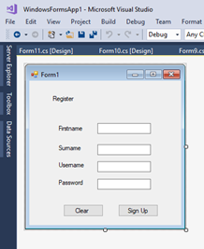

**Figure 2**: Student Register

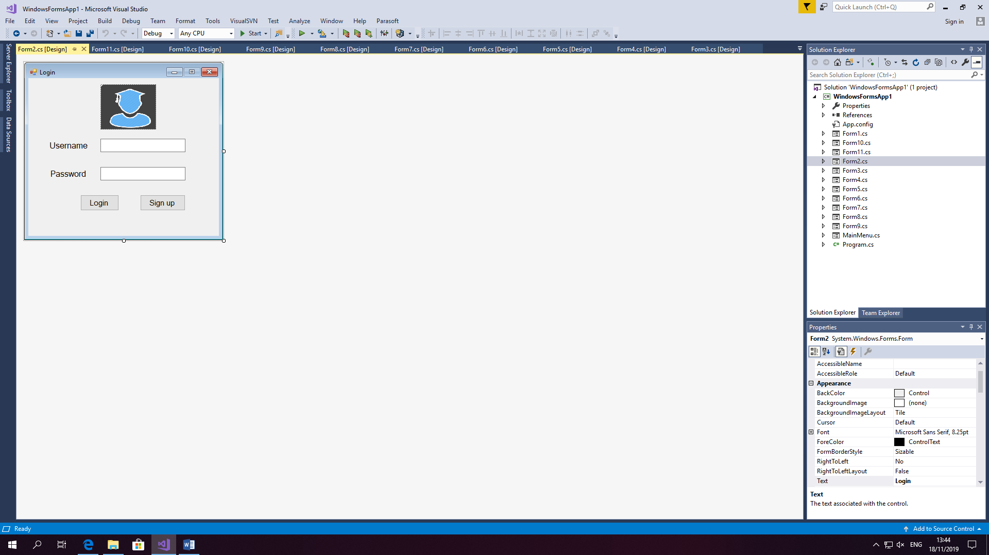

**Figure 3**: login page

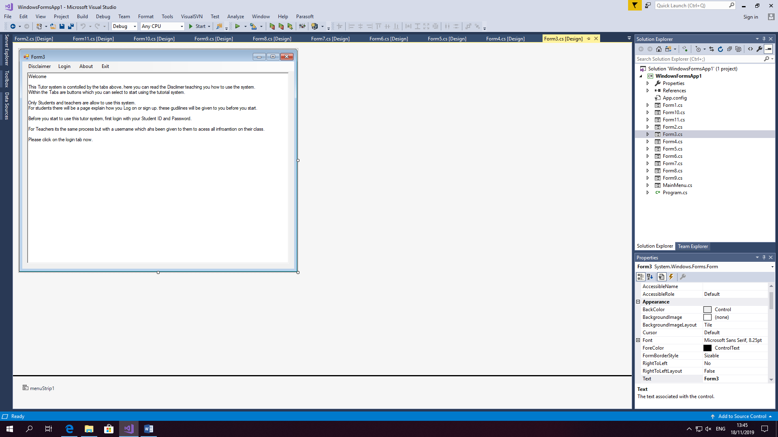

**Figure 4**: Disclaimer window before logging on.

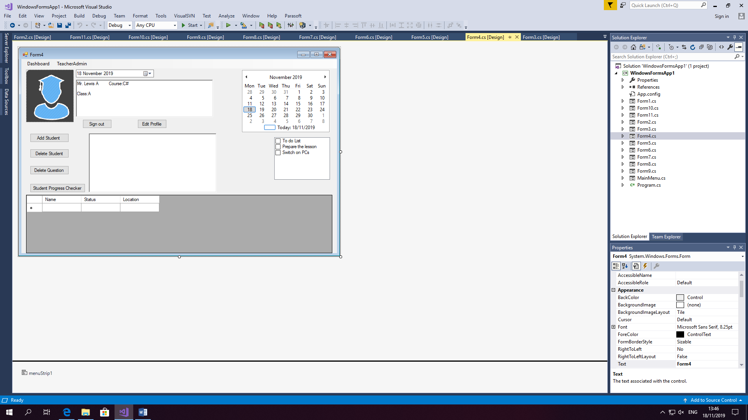

**Figure 5**: Teacher Admin when the user logs in as a Teacher

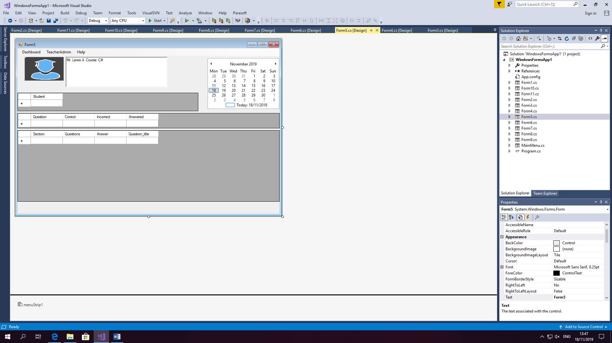

**Figure 6**: Teacher Dashboard

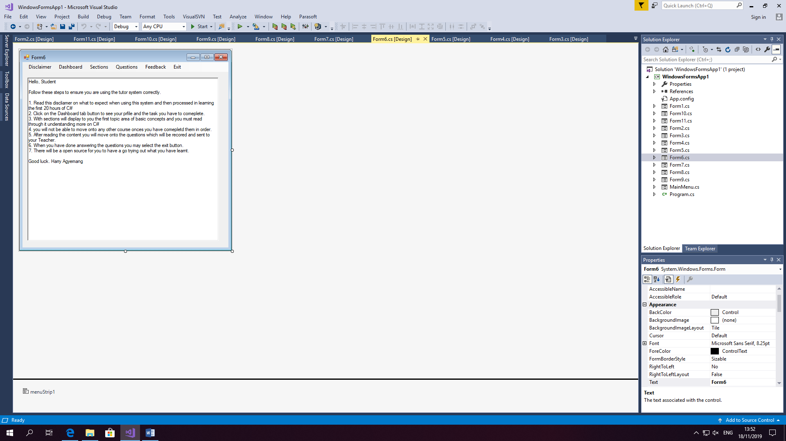

**Figure 7**: Student disclaimer when the user logs in as a student.

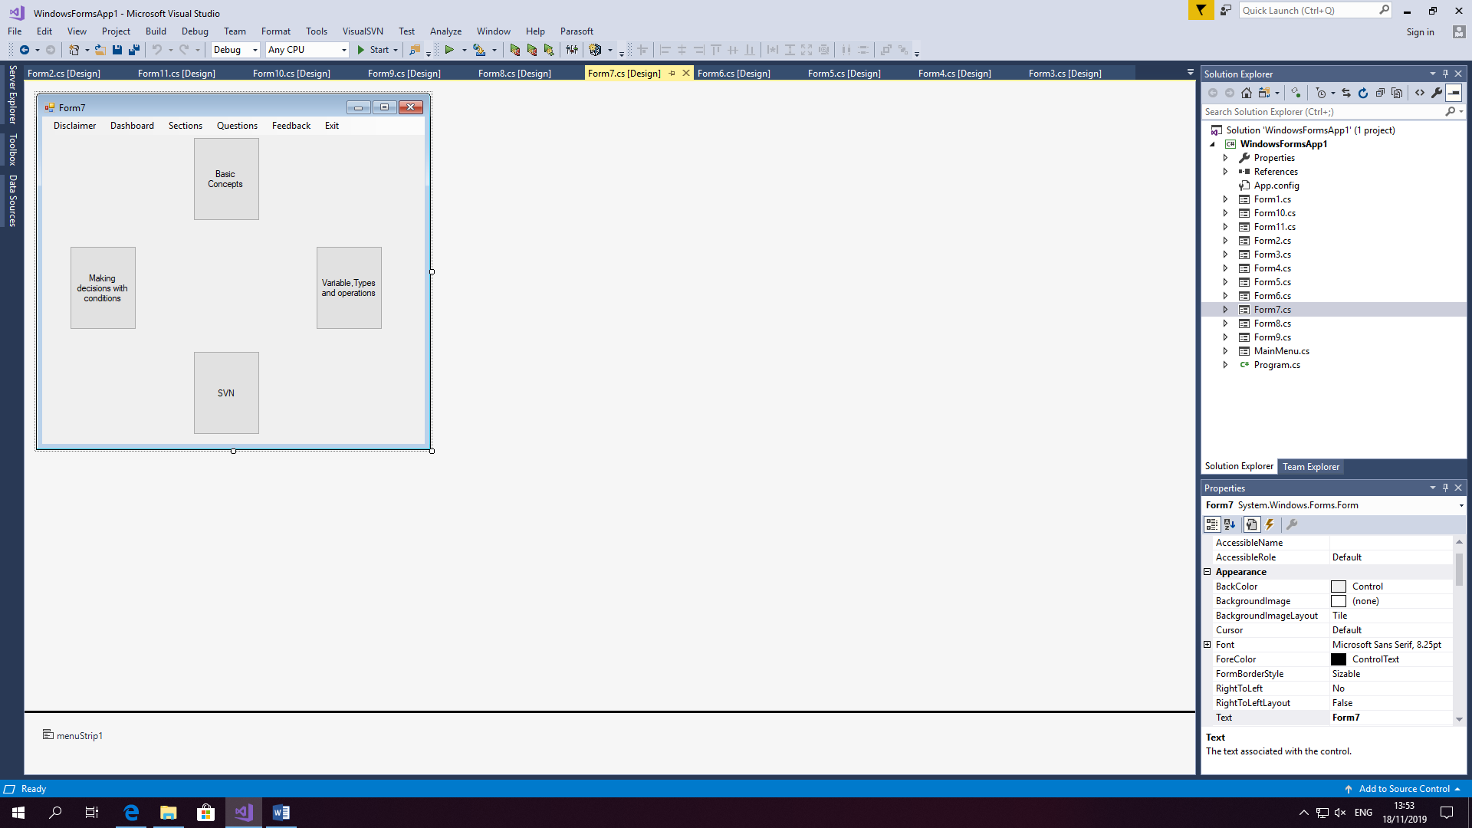

**Figure 8**: Student Dashboard

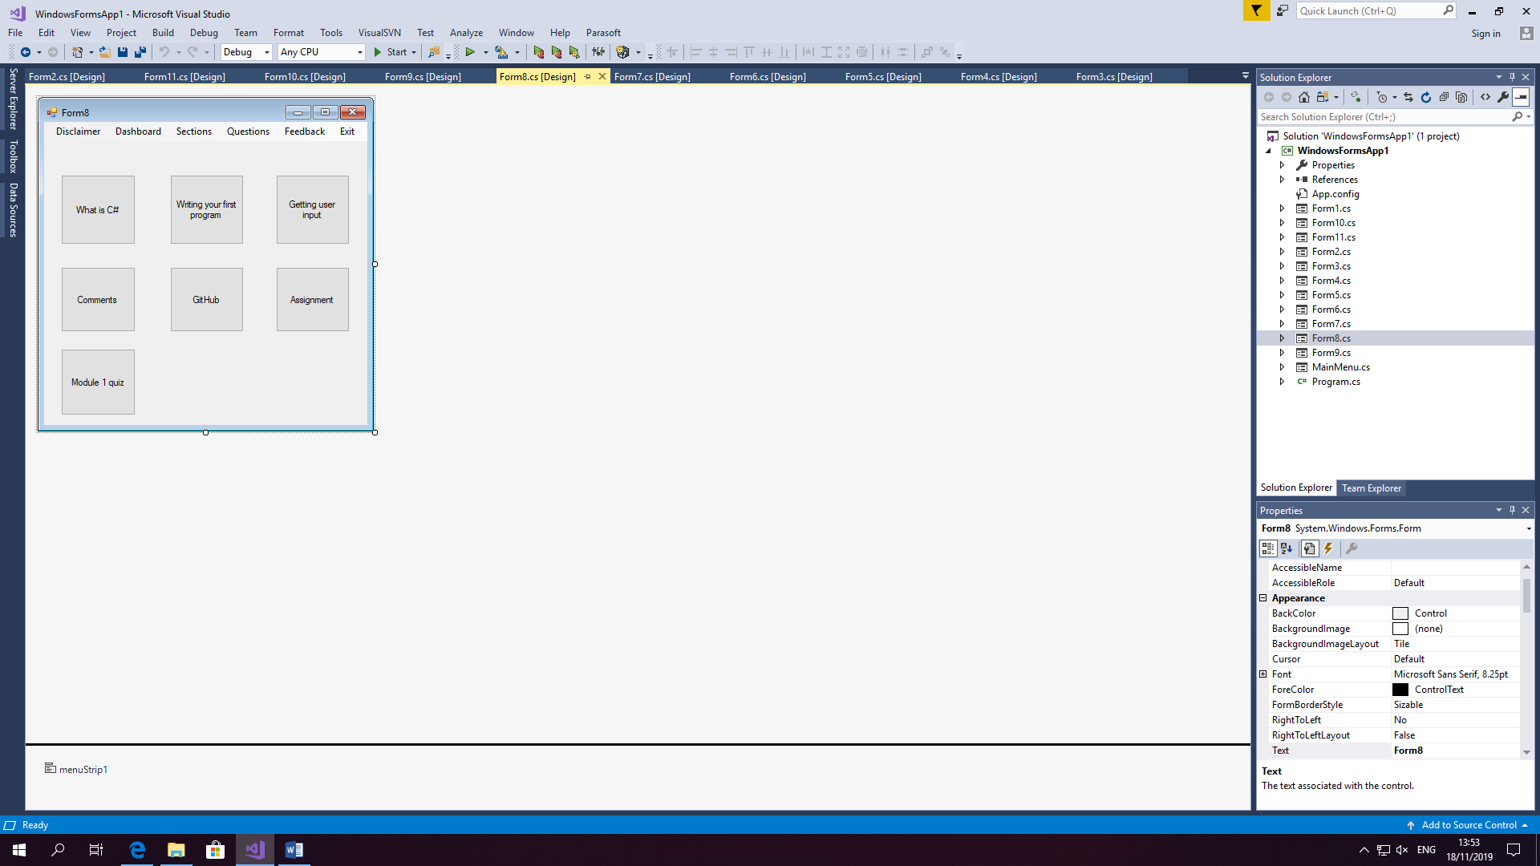

**Figure 9**: Sub-topics under the section.

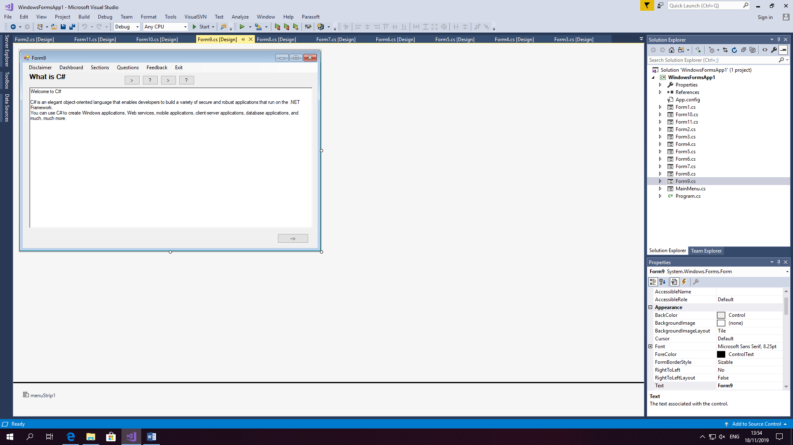

**Figure 10**: C# topic window, explain what C# is.

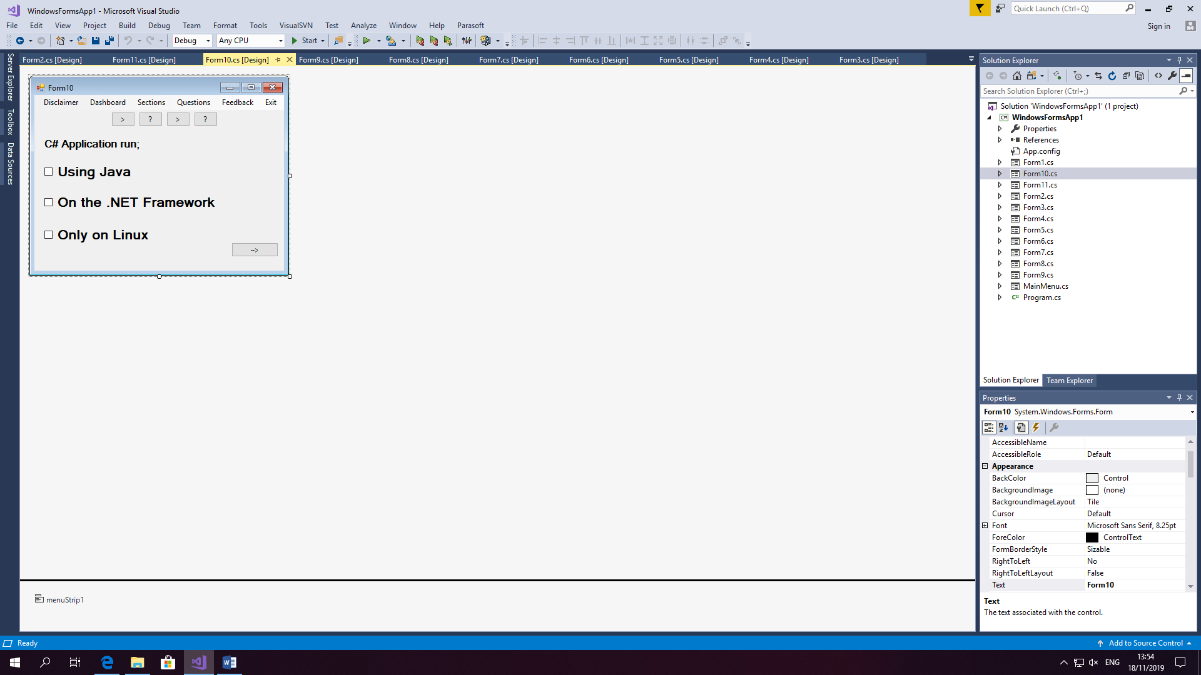

**Figure 11:** Module 1 example Question

### Remedial

The tutorial system uses a remedial function for when students attempt the module quiz. The Remedial function close the gap between what the student already knows and what they know. The Module questions uses this function for when students complete the module quiz and don't get above 60%; then they will have to repeat the test.

This tutorial system uses a remedial function to teaching students the course material on , it assesses the student on what they have learnt and whether they are ready to move ahead. This is because the remedial function targets weaknesses in the course they are studying. The aim is to help students that are falling behind to learn to the best of their ability. It is all about adapting to meet the individual needs of the student and overcome learning difficulties. (The Understood Team, 2019)

**Examples:**

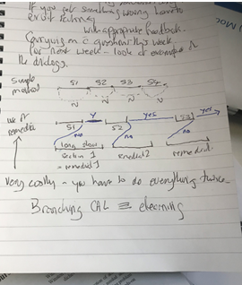

**Simple**- If you get it wrong then you go back again, e.g. there are different sections Section one, two, three and four.

**Expensive**- Have a section on there. Then you have an even longer slower version of section one there. Which is slow and explains everything. Using different languages and describing things in an alternative way, it's not reiterating it but saying it differently. You have regular section two and a remedial one.

**Figure 1**: Example of both experienced and straightforward remedial programs

The tutorial system will have the teaching strategy of an individual educational programme implemented to teach students C# and help with the learning needs of the student. It aims to reinforce foundations of learning, for example, overcoming their difficulties and developing to reach their full potential. In this case, the tutorial system will use this strategy for the whole course. Students will use the remedial function to fill in gaps in their knowledge. (educationbureau, n.d.)

**E- Branching**

E-branching can help learners to practice and keep things interesting and improve their ability to retain information. It involves how the tutorial system can better engage the student in this example of branching. The branching for specific content to make detailed, comprehensive content which is more accessible and relevant to an individual user. In this case, the tutorial system is made for students and adapted to the students' needs by making it simple and applying a teaching method for a University student to understand the content and be able to complete the test after. (Karaolis, 2019)

Branching scenario places student's in a situation where they have a problem, and they are required to make choices in what to do next to progress through to the next stage of the learning process. The benefits of using it are to boost interactivity and user engagement as well as developing the student's critical thinking ability. Another is that having immediate feedback branching scenarios can allow students to learn from their mistakes taking ownership of their decisions and try to make the correct decision. (Sanal, 2018)

### Learning Experience

Learning experiences refers to any interaction, course or program which takes place in a classroom. Learning from traditional interaction is students learning from teachers. With new technology in the classroom's students can get access to addition facilities enhancing their learning experience such as, students can email teachers, and they can use online course management to access teaching materials, e.g. assignments. Students can also use software programs, for example, a tutorial system to learn in their own time and at their own pace without instruction from teachers. Lastly, students can learn from videos created by teachers and conduct online research to determine more about the concept (Great Schools Partnership, 2013). A good learning experience adds value to the learner. The impact of being visually rich, interactive and making learning enjoyable is essential. Lastly, prolong further understanding. These experiences should inspire students to become long term learners and encourage them to pursue education beyond the course. (Smartsparrow, 2016)

Using A.I. for learning purposes can make education more accessible and suited for the individual, providing students with a more personalised approach. As a result , the efficiency of learning improved. Personalised education allows the student to have a better learning experience; this can bring better results overall. Adaptive learning responds to students' needs, and emphasises topics, repeating them for the student in need to improve and helping them learn at their own pace.

Automated grading- grading takes up a large amount of teacher's time. For example, an intelligent system includes giving the test, grading and suggestions for improvements. A.I. can handle multiple choice and fill in the blank questions for classification.

Improve courses – A.I. can help teachers improve the way they deliver the course by pointing out gaps in their lectures. For example, Coursera has used this. (Coursera, 2017) Many students submitted the wrong answer to an assignment; the system will notify the teacher if an error appears instead of sending it back to do again. It will alert the human-computer but trying to do it automatically, handing the same issue. This system helps fill in the gaps that occur in the course. Rather than waiting to hear back from the teacher, students will get instant feedback to help them understand a concept and remember how to do it correctly next time.

AI tutor- Intelligent tutorial system simulates one to one personal tutoring by delivering learning activities that best match the learner's cognitive needs and providing them with instant feedback without a teacher having to be present. The system uses a machine learning technique to determine the best content to cater to each student on the course.

Feedback- can monitor students' progress and notify teachers when there's an issue with students' performances and provide feedback. With the A.I, they can see exactly where they are going wrong and received advice to improve.

**Smart content**

Smart content can produce digital content at a high quality for students to learn and understand sections. Can also include actual content in video lectures provide that students sign in and join the conferences to listen into what's being teaching from the lecturer. This will be teaching textbook information and bring it to a new platform of video lecturers. One example is a mechanism that uses A.I. to make textbook content more understandable and easier to navigate with summarised chapters and practical test at the end. The other example is an existing tutorial system which allows lecturers to create electronic curriculums with assistance programs audios and illustrate videos for students. The impact of technology on learning will create adaptive learning environments with customised tools for improving the current standard of student learning. A.I. can allow the system to perform automation of administrative tasks and lowering the time tasking to complete a difficult so educators can spend more time with students to help improve their grades. (Johnson, 2019)

### Educational Data Mining

These techniques track student's behaviour, for example, collecting data on attendance, assignments and students. This information can give support on their way of staying on track of their education. (Software House That Helps You Innovate - Neoteric, 2019)

E.D.M. aims at the development of methods, for example, exploring the unique types of data that come from an educational context. The data comes from several sources, for example, data from traditional face to face classroom environment, educational software, online coursework and tests. These sources provide a vast amount of data which can later be analysed to figure out student behaviours in the classroom. E.D.M. is contributing to educational research, as there are problems. It has influenced the thinking of pedagogy and learning and has promoted the improvement in teaching software and individualising students' learning experiences.

Most data mining techniques include classification, clustering, and association analysis to an educational domain. The educational system has a characteristic which requires different treatment of mining problems. (Romero et al., 2010)

**Classifier for educational Data mining**

The classifier places an objective into one class or category based on its characteristics. In education, teaching classification to their students on such things like knowledge, motivation and behaviour, by assessing exam answers, where marks are determines according to the evaluation criteria. Automatic classification is a part of an intelligent tutoring system and is adaptive to a learning environment. Before the system can select tasks and learning material, it should first classify the learner's current situation, for that reason, it is necessary to add a classifier—E.g. That predicts class values from other attributes. For example, it could indicate students who are likely to fail or drop out from their test scores. These predictions are useful in traditional teaching, but computer-based learning systems are used in large classes and collect data to be used for derived classifiers.

The first classification method, for example, decision trees then collect a sample of data to divide into a training set and test set. Training data used to a learning algorithm which derives a classifier and then tested with the test set. If there are more cases, then the test set is correct and works accurately on future data. But if the classier makes too many mistakes, then we can assume that the wrong model. This task requires different classification approaches, data manipulations and algorithms set before a good classifier is found for example, a group which consists of classifying the student's success on a course.

The objective was to predict passing/failing a course. It was taking in all considerations of student's activities in the way. Classification methods in the experiment, e.g. k-nearest neighbour and regression techniques, and the average accuracy in its best case were 90%. What affected it was the number of class values used and how early a stage the predictions were made. (Romero et al., 2010)

### Constraints and Limitations

Time- The epidemic has caused the country to move their operations online, for example, organising group meetings via video chat. This has affected the timescale of the project as it will have to be delivered later than the original deadline date.

Ethics of content- the tutorial system is required to provide students with the correct information. Providing students with material which is 100% right and is checked with publishers and course leaders before being taught. If not, this project will be breaking the ethics code and can face legal action for giving false information.

Accuracy- With this project, there is a limited amount of time to be completed. If there were unlimited time, then the project would be covering the entire content on C#. Anderson et al. (1995) suggested teaching the first 20 hours. A way of scoping the project as if you'd done all of it. The focus should be learning the twenty hours as most of the issues will come in this area, and then getting the rest should be similar. It's all about sensible scoping on the content of C#, which is relevant to teach to students as this will cover the main areas students should master first before moving onto advanced topics.

## Design constraints

Design layout- a significant constraint will be to do with features such as the section windows on the tutorial system. The windows would have to be designed in a way for students to understand the text and view clear and detailed images. The constraint would be the design of windows having large amount of while space and not looking professional. Another would be the structure of the text to examples. Ensuring that the context is correct and organised in the right manner can prevent this constraint.

Usability- The framework of the tutorial system designed for both student and teacher, but recently changed and have decided to go for a more conventional approach. For example, additional types of questions, e.g. drag and drop. The constraint in usability is the tutorial no more needs the teacher profile and has gone with a conventional tutor system. (Spacey, 2016)

## Design

## Version Control System

A version control system acts as a chart for a project, which allows team members to stay up to date with changes and add new improvements. For example, SVN is a version control which will enable members to check the recent version of the code and check-in changes they made to the repository. There is detailed history on all changes made, and if anything goes wrong, the team leader can revert the code back to its previous working version. There are different models of a version control system which all have a different function:

- Local data model: this is the purest form of version control, and it requires all the developers to have access to the same file system.

- Client-server model: in this model developers use a single shared repository of files. It doesn't require all developers to have access through the internet of a local network. SVN uses this.

- Distributed model- in this model, each team member works with their local repository and the changes are shared between repositories. Git uses this model (Hall, 2015)

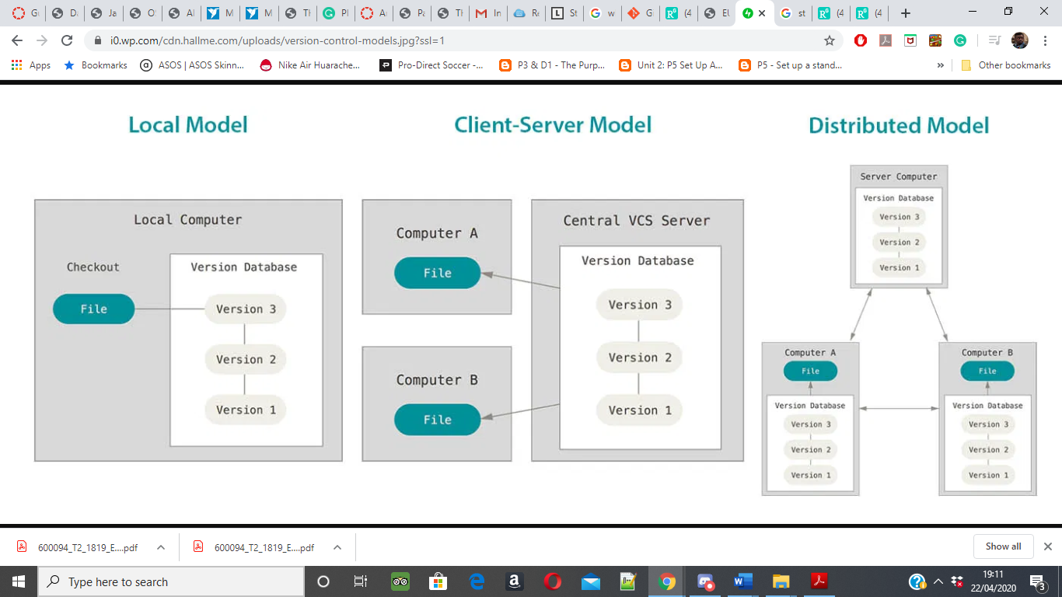

**Figure 12**: source come from (Hall, 2015)

## The C# architecture

**The C# architecture has four components- Model within the tutorial system**

**Student model** – Student using the C# tutorial system will have their profile in the system or would need to create one. Within the profile contains information on the student about their name, student number and relevant details.

**Tutorial model** –  This part controls the functionality of the tutorial system. From here, students can access the module content on each section where it provides information on the scope topics. Then students would move onto completing the module quiz for each one and will have to get a score of 60% + to move onto the next section otherwise they will be taken back to the lesson to do the exercise again. This system allows the student to repeat it until they are satisfied with their results.

**User interface**- The system interface is designed using Windows forms tools, this is for interaction with the student and creating a dynamic way of teaching programming. This interface mainly focuses on the student window. The system shows how students can view information on section, exercise and results. (Al-Bastami, B, and Ab-Naser, S.S. 2017)

**Expert module**

The tutorial system contains the course material to be taught to students. In the tutorial system, the material will have the following sections within the first twenty hours of CSharp:

1. Introduction / Disclaimer
2. Understanding Computers and Programs

- Computers

- Programs and Programming

- Programming Languages.

- Module Quiz

1. GitHub
2. Basic concepts- Simple data processing

* A First C# Program
* What is C#
* Combining Logical Operators
* Manipulating Data
* Module Quiz

1. Variables, Types and Operators

* Assignment and Operator
* Comments
* Methods
* Exceptions
* Module Quiz

1. Making Decisions with Conditionals

* The if Statement
* Switch
* Logical Operators
* Basic Calculator
* Module Quiz

1. Loops

* Loops
* while and do-while
* break and continue
* Arrays
* Parameters
* Module Quiz

End of the tutorial system

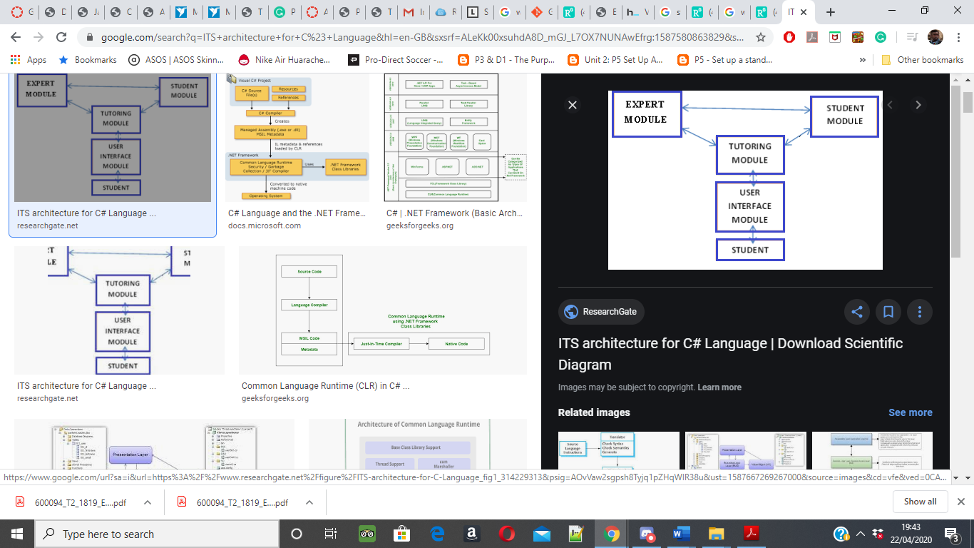

**Figure 13:** ITS Architecture for C# (from  Al-Bastami and Ab-Naser, 2017)

**Example tutorial system**: Solo learn

Solo learn it is an application used by user to learn a programming language. It has many programming languages which users can study by selecting the course and completing the module test at the end to earn a certificate. Solo learn is a mobile app but can be on a web browser. This platform offers free courses for beginners to learn programming languages, for example, HTML, CSS and C#. In these courses are topics which learners must read through the content and illustrations, then move onto the quiz where it gives questiosn on each concept and helps improve learner's basic knowledge.

Learners use code playground where they can display their coding ability to the community. They can see other learners' creation, e.g. chatrooms and games—allowing the learner to write and run their code—letting user experience and experience coding. Users can make a choice which languages to code in and start creating and post it onto the server for everyone to see. (SoloLearn, n.d.)

**Example of the C# course:**

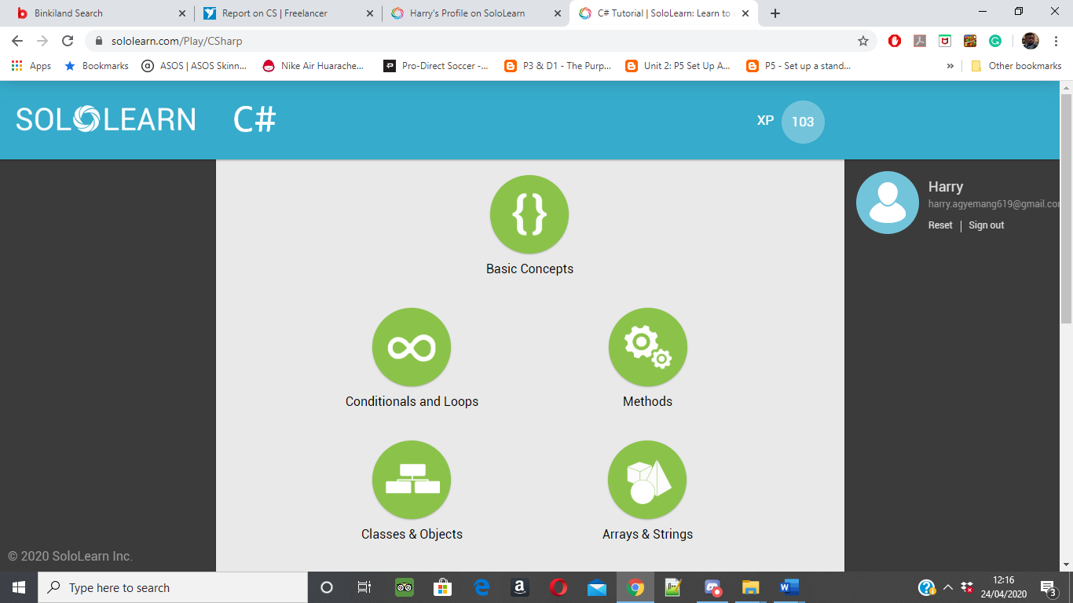

**Figure 14:** learner dashboard(from SoloLearn, n.d.)

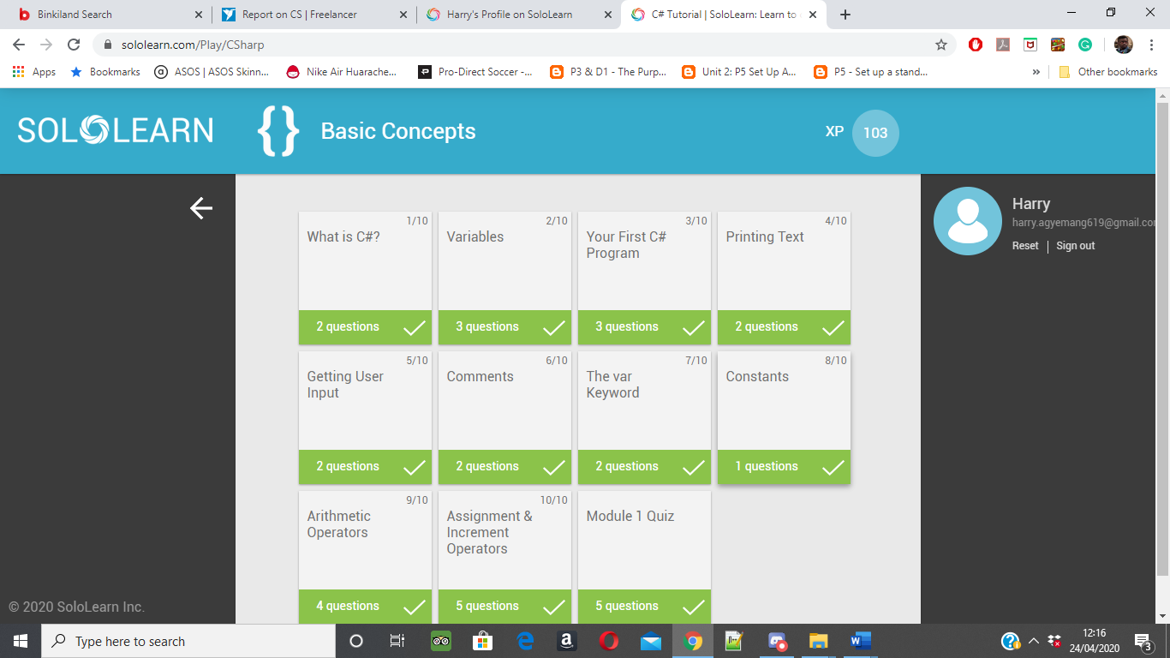

**Figure 15**: Basic concept window with subheadings (from SoloLearn, n.d.)

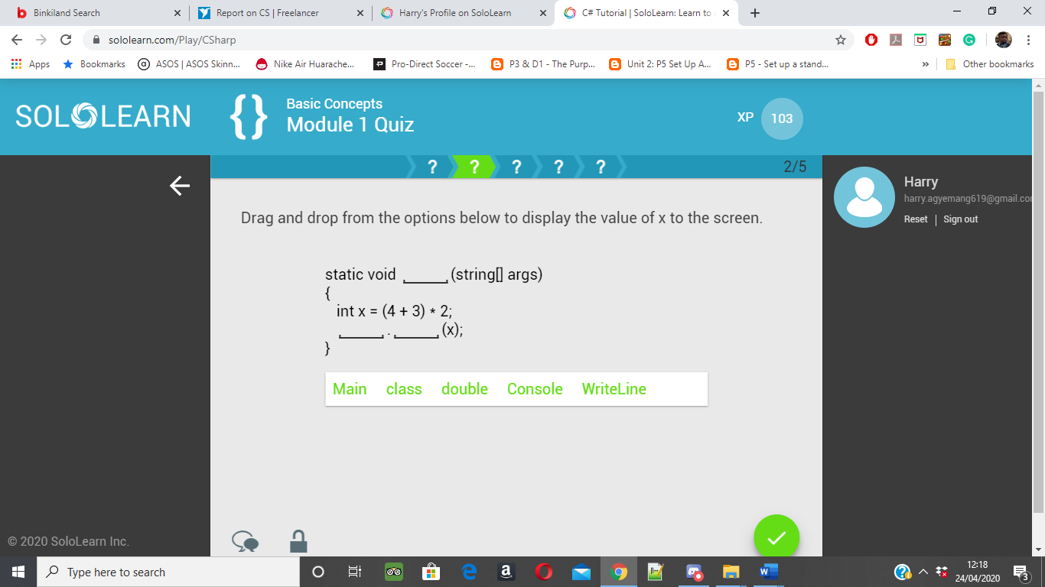

**Figure 16:** drag and drop question(from SoloLearn, n.d.)

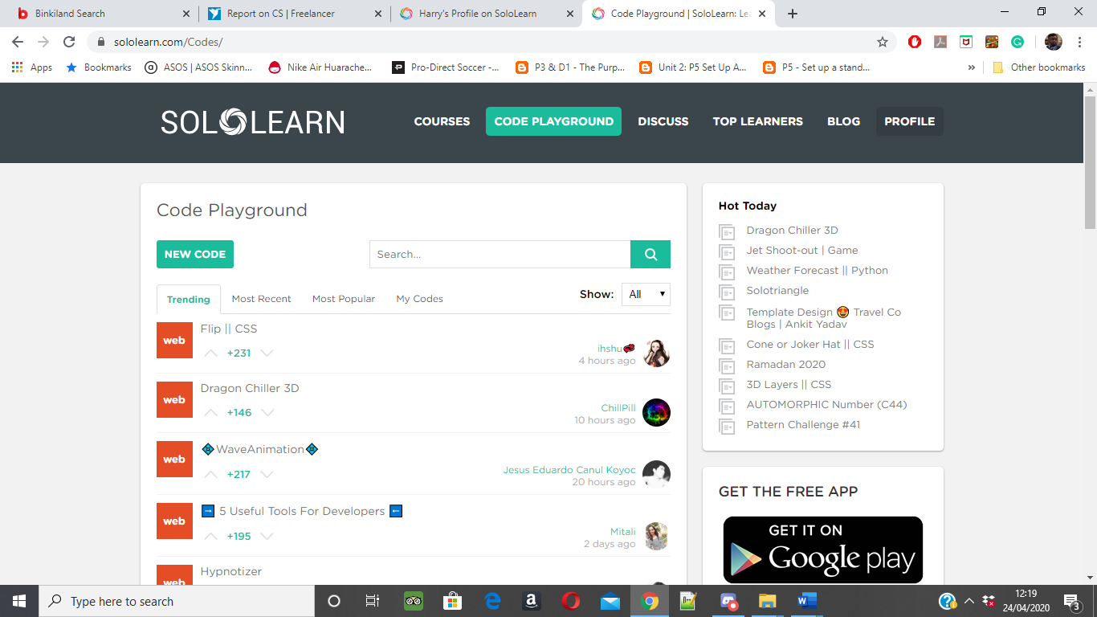

**Figure 17:** Solo learn playground (from SoloLearn, n.d.)

## Iterative and Prototype Design

A Software engineering technique used in this tutorial system is a series of designs incrementally improving upon the final product. (Pressman, 2015, p. 45). The uses of prototypes, in this case, the project follows the incremental approach. The importance of this is the models are tested on users. The problem faced is time as prototyping cost time and takes away from real design and planning.

The technique used for prototyping is storyboard. It gives a graphical description of the appearance of the intended system. Show the user interface and telling a story of how uses go from one end of the system to another, achieving the aims and objectives it set out to do. With prototyping, there needs to be an understanding of what it is wrong and how it can be improved. (Dix et al., 2004)

**Prototype Design**

The designs will follow a prototype model for each iteration. First, the requirements are top priority and creating content pages which suit the user's needs in understanding text with an example would have to be implemented into the system. Another is creating different types of questions which challenge the students thinking and develop new and inventive ways to ask a question on C#.

There have been ideas draw on paper beforehand, and from there a lot has changed. For example, there will no longer be a teacher window and extra features to the multiple-choice questions will be added to satisfy the needs of the stakeholder and customer.

## C# tutorial- Sketches

This section will go through the story of designs, how it went from drawings on paper to the final product. The sketches will show how certain aspects have changed throughout this project, but the purpose and features remain the same but with added functions.

The importance of the initial sketches is to show the design process of the software. It tells a story of how it went from the first stages of drawing to the finished product. The drawings help create ideas, demonstrate functionality and illustrations that requires human interaction. Below are the initial sketches of how the system would look like then later would be developed using windows forms. The beginning stage is understanding what needed, so, for example, having a student and teacher platform. These would be the initial designs of the project but later change.

The first stage is research, before sketching there would need to be an understanding of the problem that is going to be solved, so, for example, looking at the project objective of how the system must function. In the design plans, there must be explicit instruction on how to use the tutorial system for students to use it and be able to learn the content on C#. For example, in the existing tutorial system, they have a different way of delivering content, and the system teaches C# to students though content and examples. Sketches help with drawing out an idea before converting these onto the computer editors.

It is essential in this case for the sketches to still be a part of the final project because its general ideas are what makes the system, but during the development, some can get removed, and others can and improve. Sketches can help explore and explain the design process; for example, in these sketches below it shows different examples of windows in the tutorial system (Figure.17). This page will contain information on welcoming the student/admin to the system.

These sketches show the user experiences of the system. The illustrations present the initial steps users take to starting the tutorial system. The benefits of having drawings are feedback can be verbal, and this can help amend the pictures on ways to improve it. It can be from peers or a project supervisor that can give feedback to help them understand it better and offering suggestion on making it better. The best ideas from the sketches get put forward to provide a structured layout for the designs. Illustrations are the best process to help discover thoughts and solutions to the problem and is essential in the design and development process of the system. (Important, 2014)

Here below are the initial sketches, in the involvement of the design sketches show the tutorial system at the first stage with getting the ideas on paper. The purpose it so shows the results of the problem as in how this tutorial system work. Having core ideas, for example, ensuring it meets the main objectives and requirements and designing the user interface developed for the learner. The sketches encourage drawing multiple pages, for example, logging, content and student profile. The illustrations can help notices potential issues while sketching and then later solved. (Thalion, 2017)

**The CSharp Design Sketches**

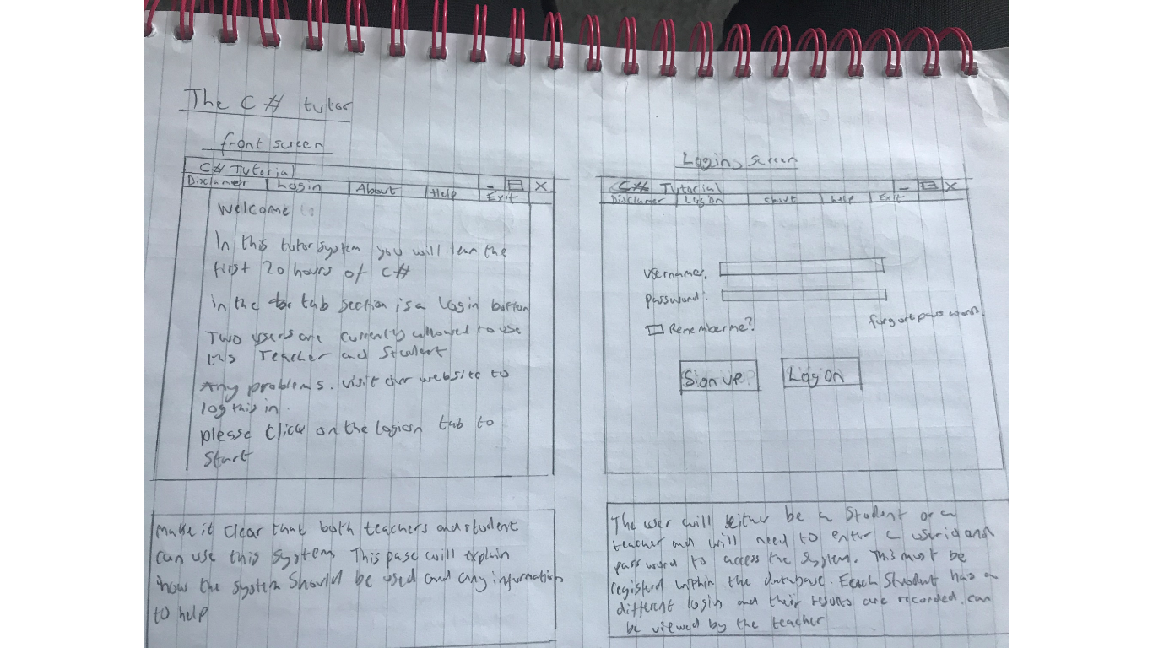

**Figure 17.**

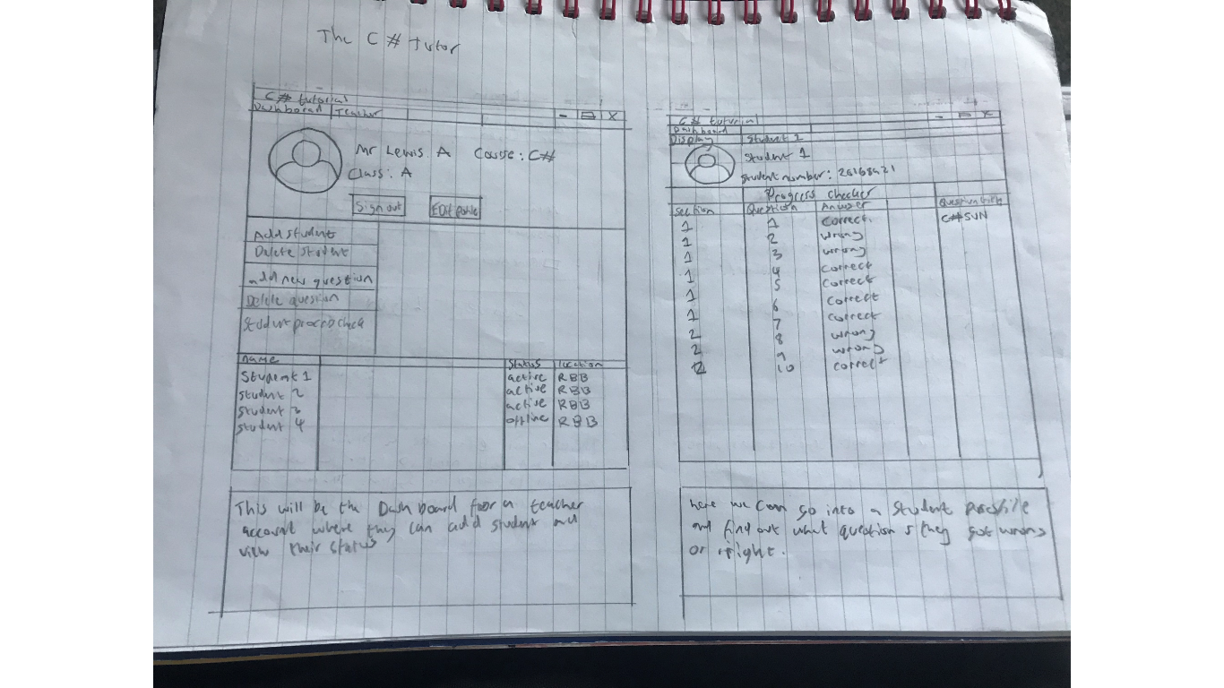

**Figure 18.**

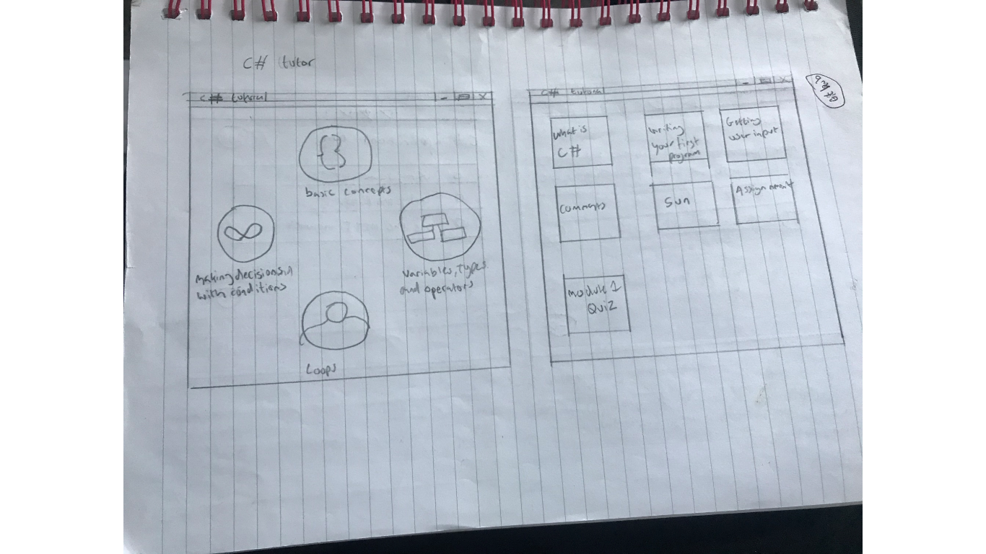

**Figure 19.**

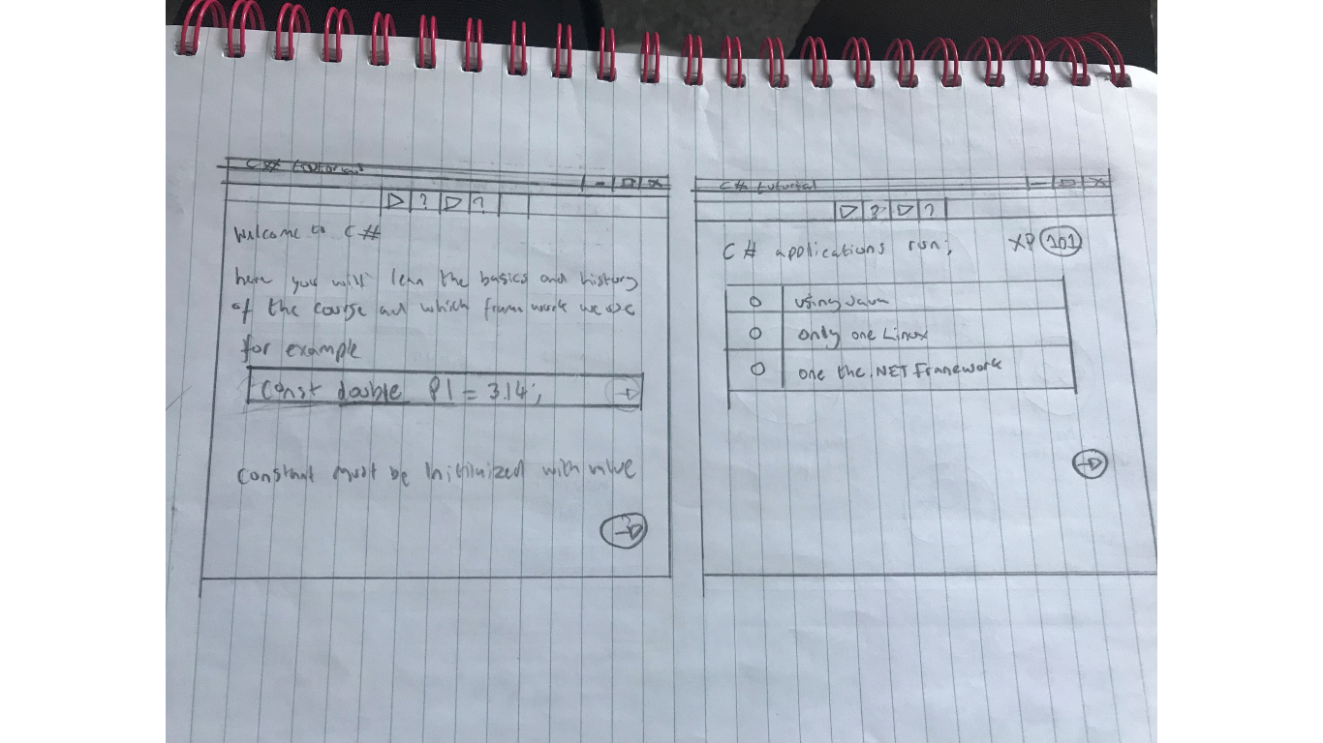

**Figure 20.**

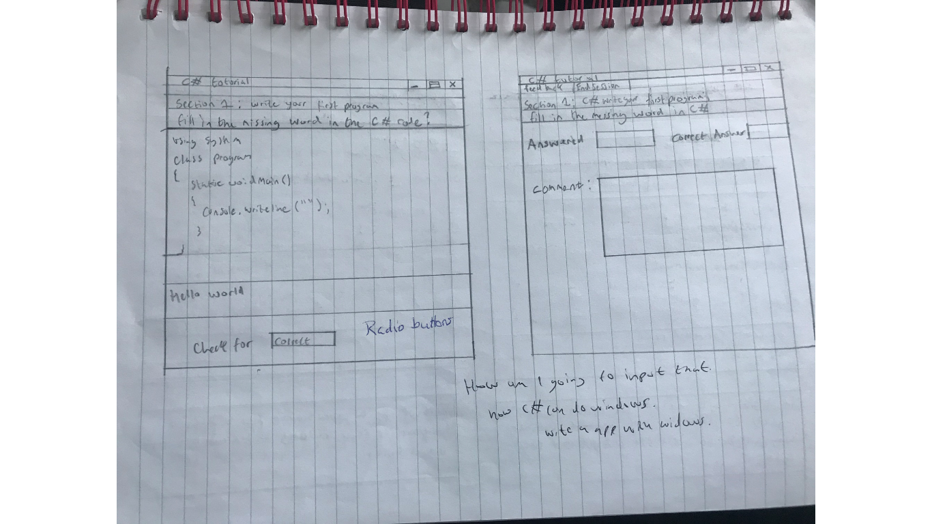

**Figure 21.**

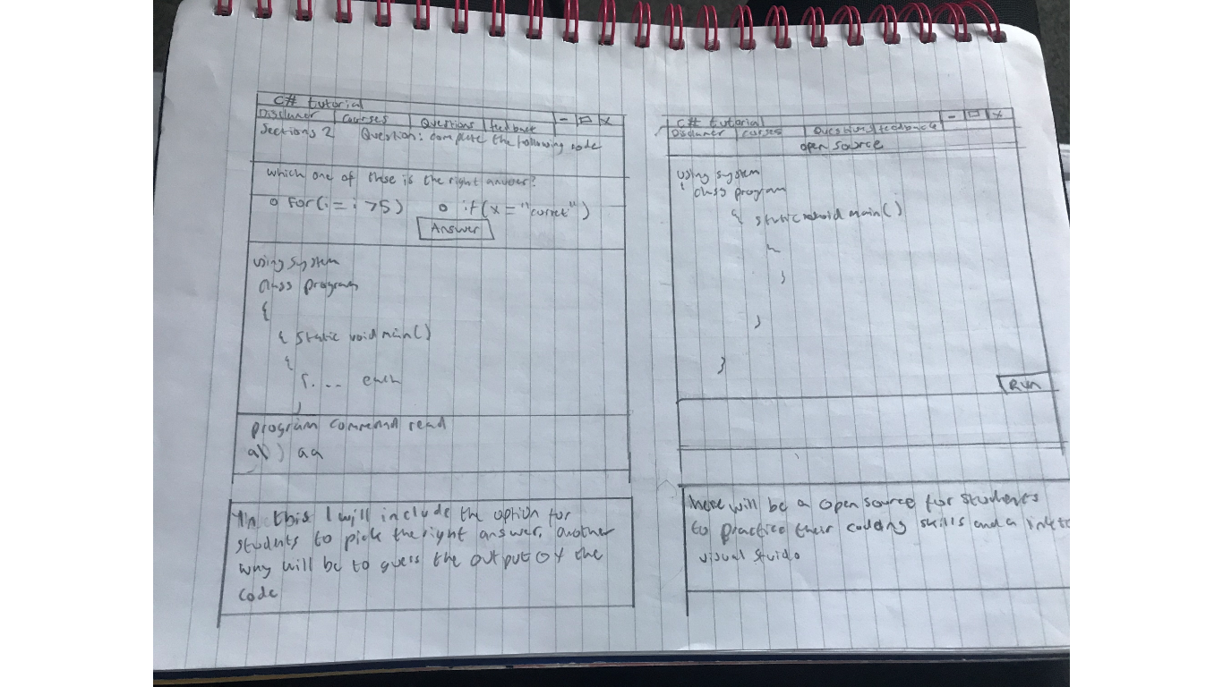

**Figure 22.**

## C# tutorial- Windows Forms

**The C# tutorial system using Window forms**

The following outlines the software working prototype, which went through dramatic changes. The design plans starting off with describing the essential functions of the system before moving onto a student perspective. But initial this is what a student would begin with before using the system, showing the journey from one end to another.

We start with the generic login

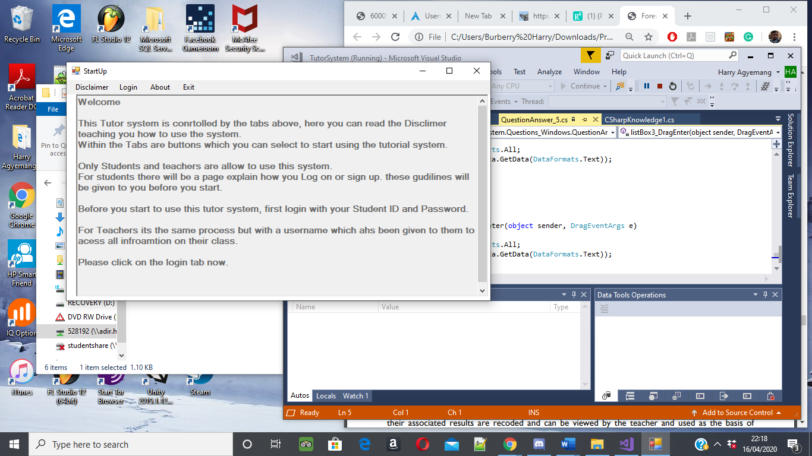

They are giving recommendations to the user on the tutorial system.

**Figure 23**: Teacher/Student initial screen

Students starting the tutorial system students will get a welcome message in (Figure 23). It covers advice on how to use the system and any general questions on the system. It directs the student towards the login tab once they have finished reading the guide. They are giving recommendations to the user on the tutorial system.

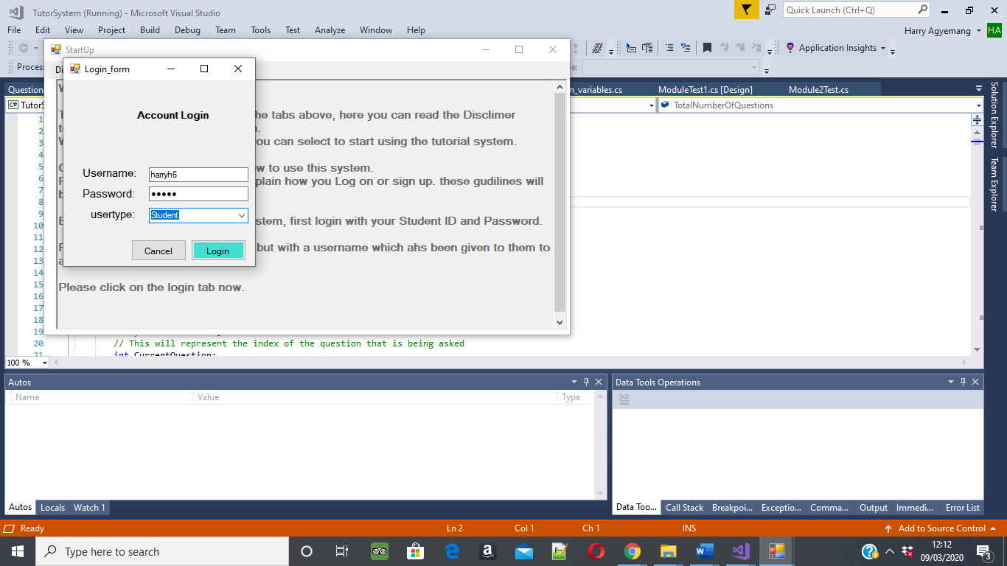

The user can be either a student or teacher but will need to enter their login details of Username and password and declare that they are a student. Only students can log in as student user type, but teachers can’t. In this case, we don’t have a teacher and so have gone ahead with just students using the tutorial system.

**Figure 24**: Login Screen for Student and teacher

Currently, user Harry1 is logging on. Each student has its unique username and password from the other students. Future changes will be for the teacher profile. For example, each students' results are recorded and monitored by the teacher.

Student walkthrough

This snapshot shows the learners’ perspective. The students first view is in (Figure 24) and then uses figure 2 to log in. Next, the student transferred onto the disclaimer tab(Figure 25) where it explains to them how to use the system and navigate around it. After the course content and module quiz.

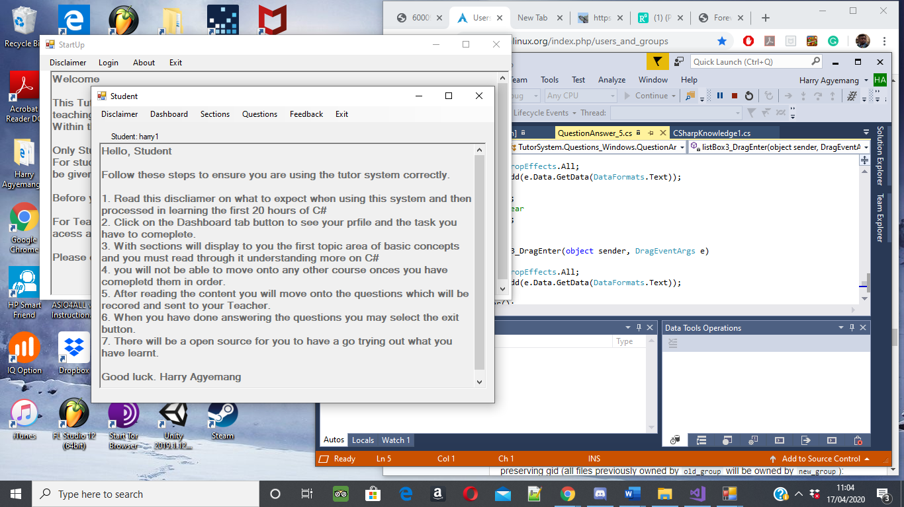

The disclaimer tab Is a list of step-by-step guides when navigating around the system suggested to students. This guide gives them advice on how to use the tutorial system.

**Figure 25**: Student disclaimer, which gives a step-by-step guide on what to expect from the tutorial system and how it operates.

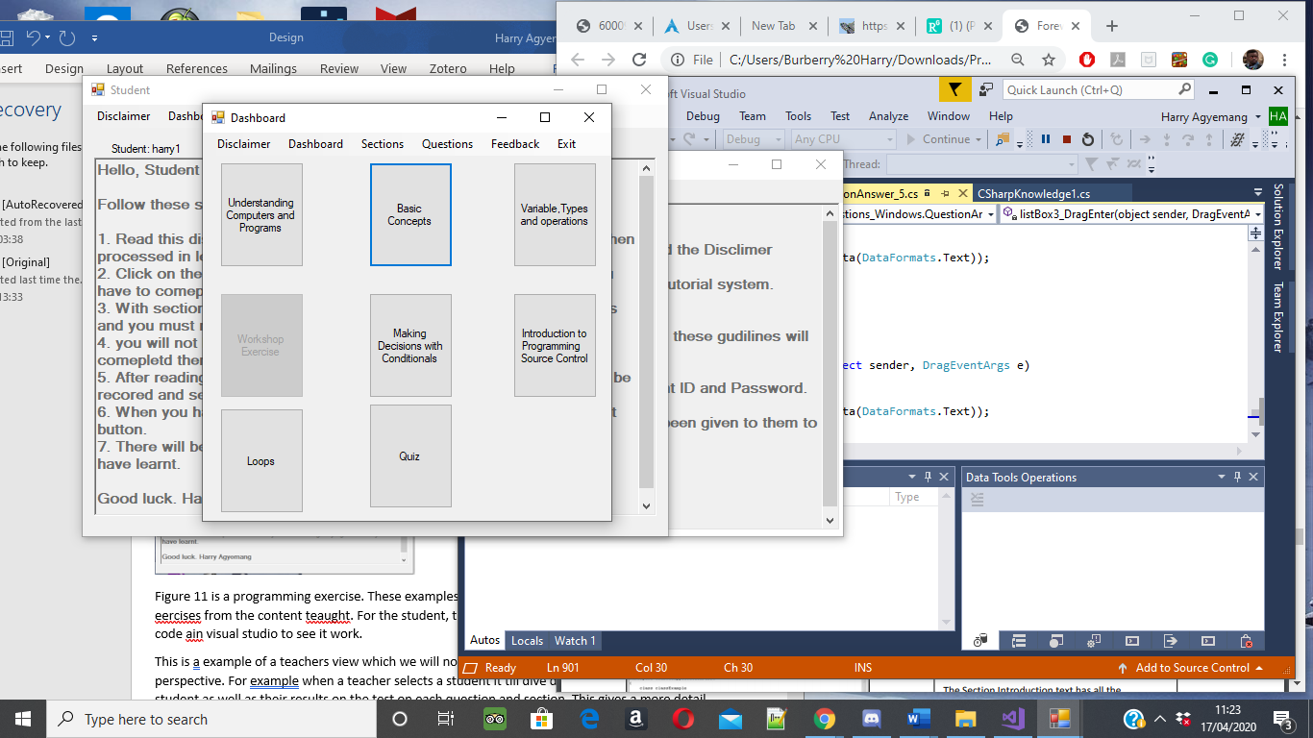

Each section is a topic on the C# programming language. Within the chapters are topics which cover the overall parts. So, when the student complete that section, he/she will be able to understand basic concepts.

**Figure 26**: An example of the student Dashboard screen

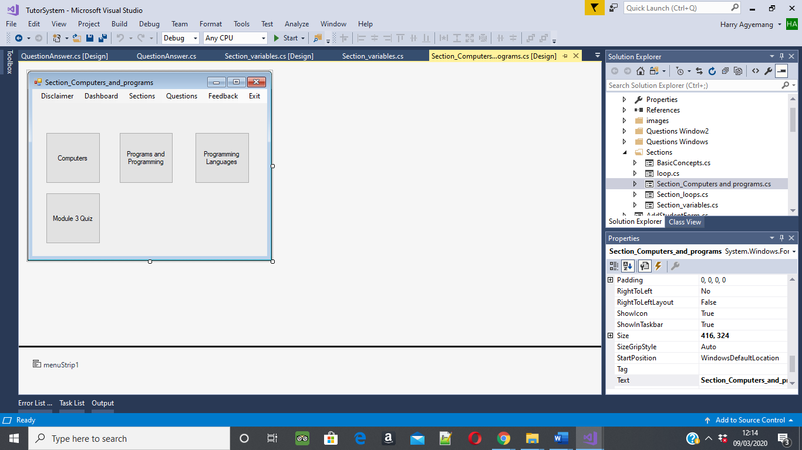

Here is an example of the understanding of computers and programs section. This contains three topic areas they must complete before moving onto the module quiz.

**Figure 27**: An example of the understanding of computers topic.

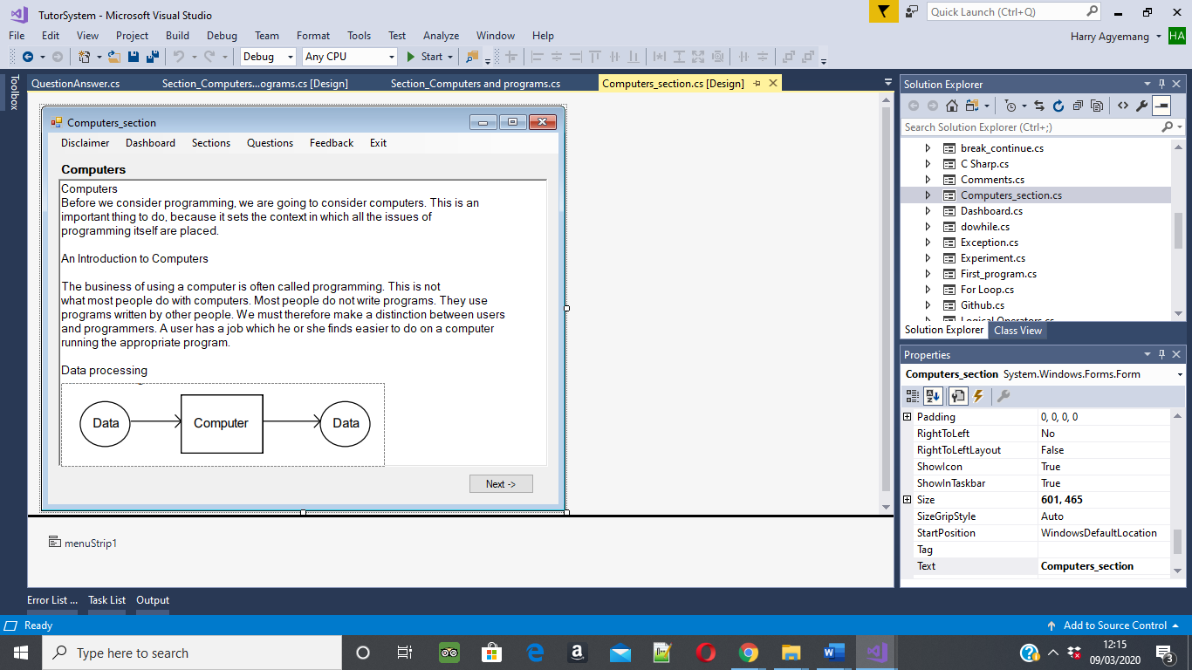

These topics carry valuable information used as question on the module quiz. Students should read through it and work at their own pace to understand. On this page gives both detailed text and examples.

**Figure 28**: Section introduction from the topic of Computers.

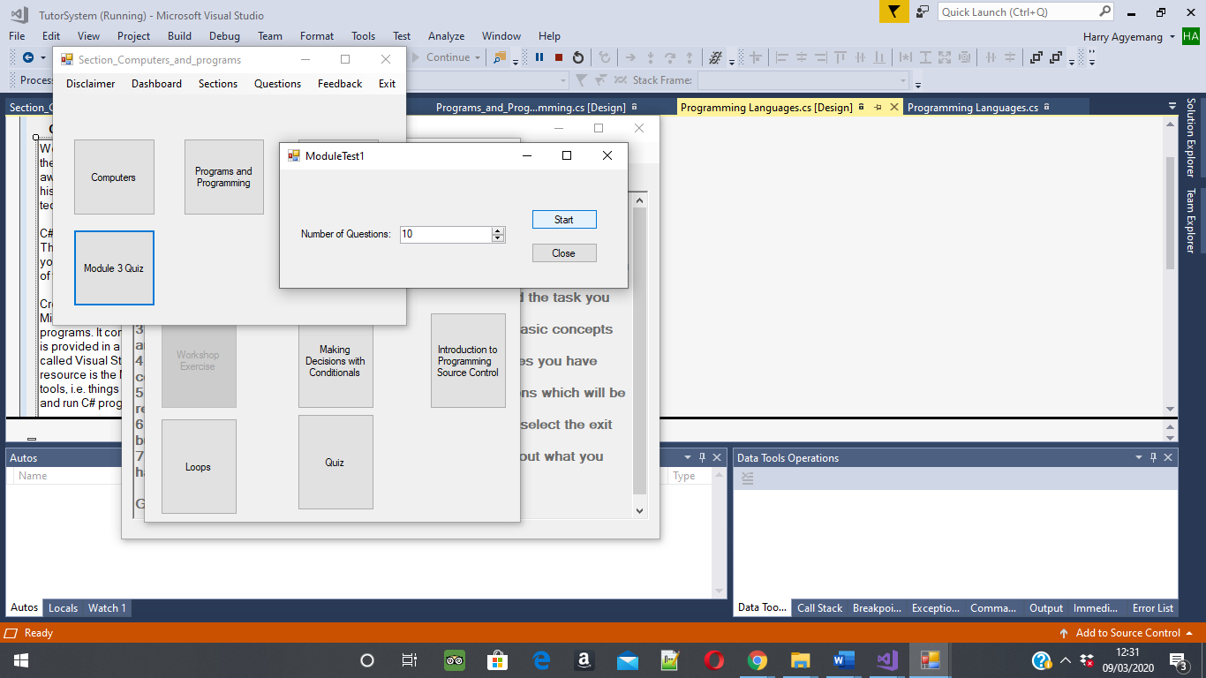

When the student complete reading through the section they are eligible to start the module quiz. Students will have to complete a minimal of 10 questions.

**Figure 29**: Module Quiz selection menu

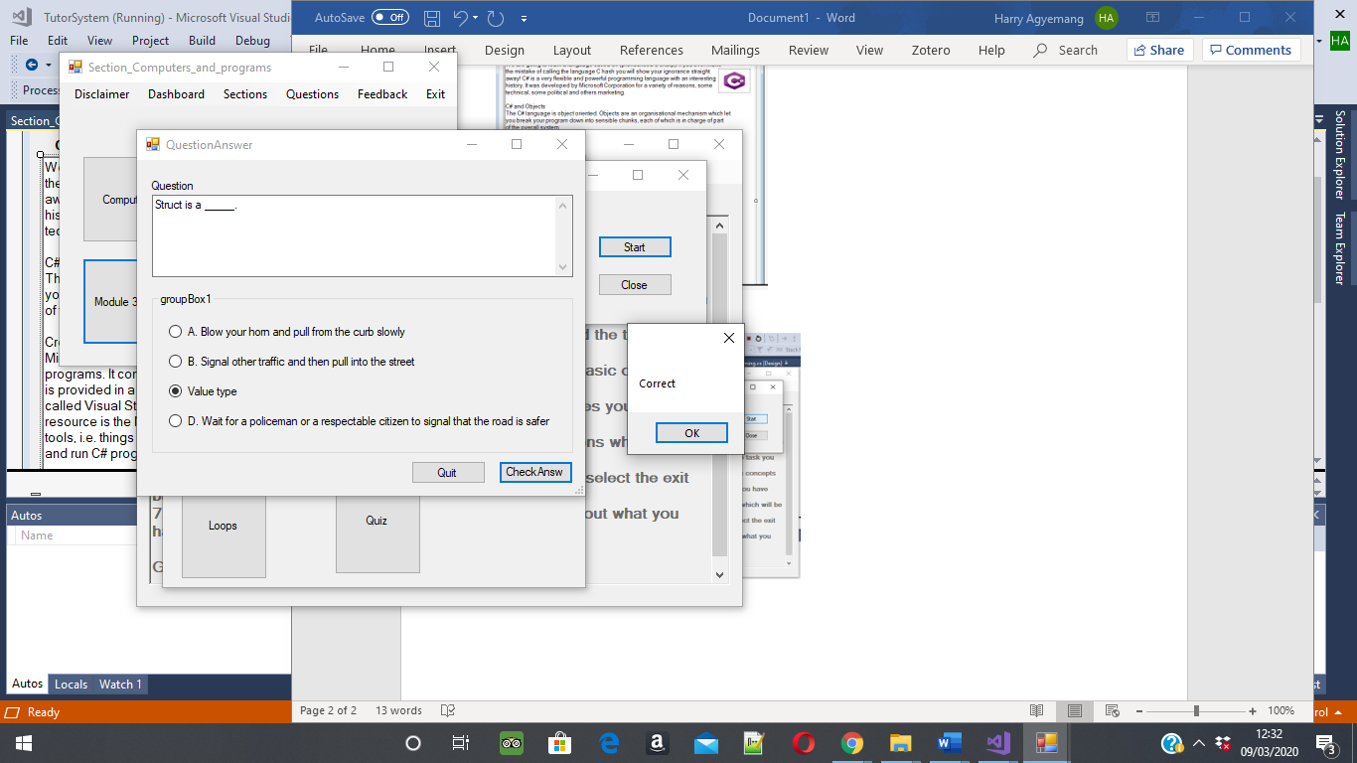

Students reading the question and select the right answer. The system will then respond with feedback.

**Figure 30**: Question and answer the Quiz menu

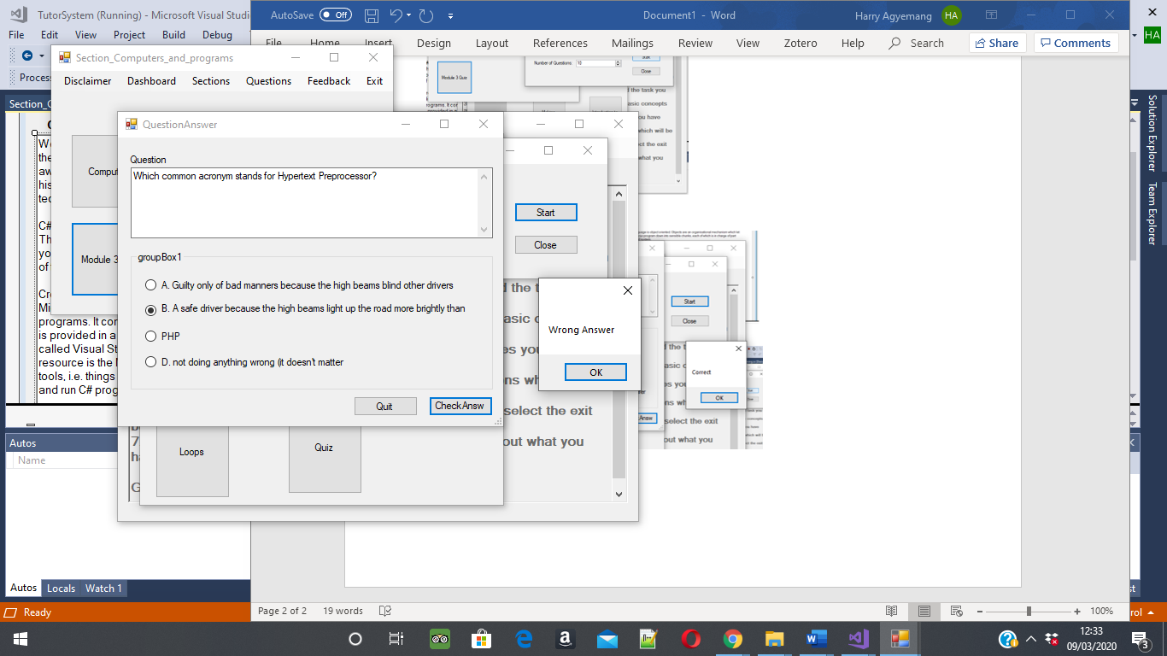

If the student gets a question wrong and message will pop up. They will still be able to go onto the next question.

**Figure 31**: Quiz menu is correct. But if wrong feedback provided

**Figure 32**: Results below 60%. Feedback on repeating the module.

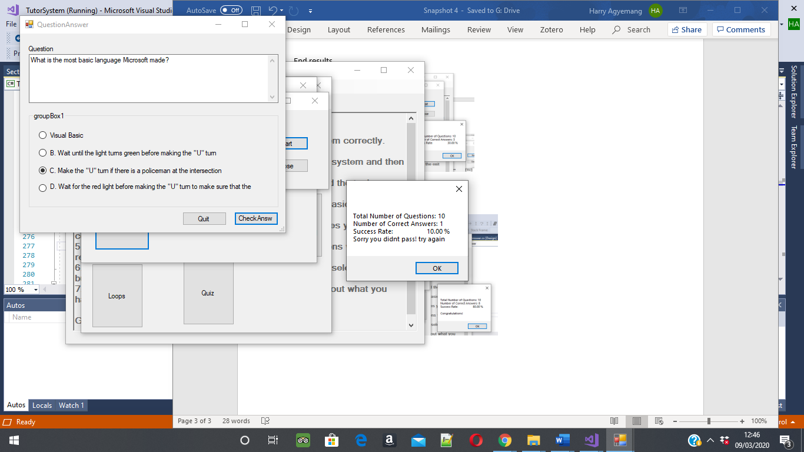

At the end of the module quiz, students will be met by a message with the results from the module quiz. In this system a remedial function is added to instruct students if they achieved above 60% then the student would be advised to repeat the section.

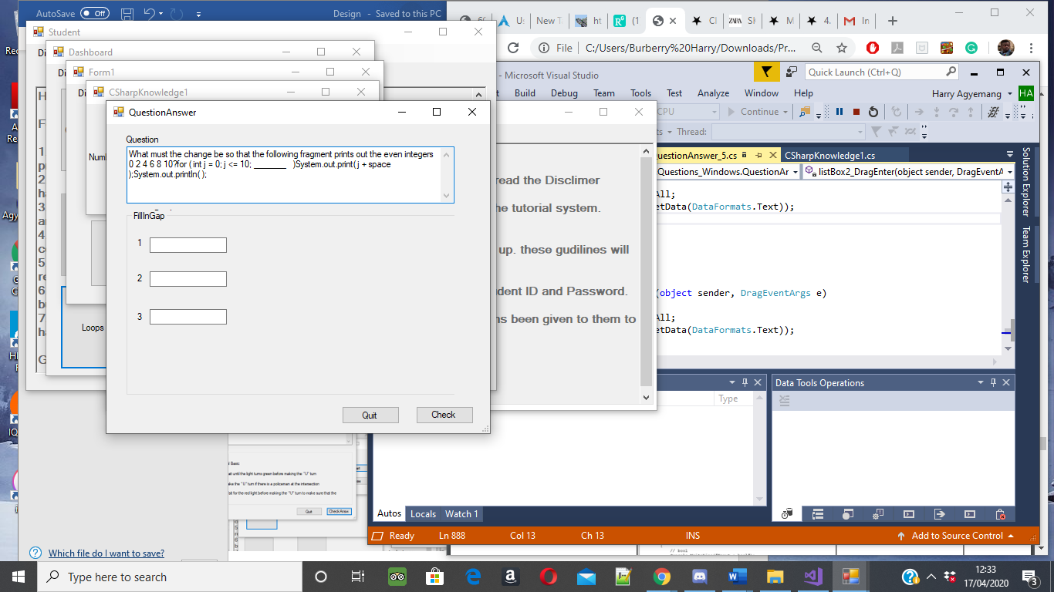

Programming exercise from the module quiz. Fill in the gap

**Figure 33**: Question and answer type of question. Fill in the gap.

Here is an example of a teachers view which we will not be including. Teacher's perspective. For example, when a teacher selects a student, it brings up detail information on the student. The teacher window gives a more detail breakdown of the students correct and incorrect answers.



Teacher's perspective- This is a DataGridVew of the current students on the tutorial system.

**Figure 34**: Teacher Admin board to monitor students within the class.



Teacher dashboard- Can view all students and their results from the sections.

Break down of all their results, e.g. Correct and incorrect answers.

**Figure 35**: Teacher dashboard to view all students.

## Computer gaming and Human-computer interaction

HCI interacts with intelligent tutorial systems; by making appropriate designs to its interface. It works by the learner having two problems to face. One is the learner must learn information on the topic which is new to them. Second, the learner must use the system to gain a better understanding. The goal for HCI interface design is to make it transparent. HCI is more of a communication problem, as its purpose is to design an interactive system built on the conceptual model. This knowledge evolved from previous computer system from human interface research (Polson and Richardson, 2013)

Human-computer interaction is showing how people and computers interact with each other and to extent it with interacting with humans. This consist of three parts, e.g. user, computer and interaction. Users require different mental models with their interactions and have different ways of learning and retaining knowledge. HCI ensures that both the user and computer interact successfully. The goals of HCI is to produce a good and functional system. Another is to achieve efficient, effective and safe interactions with people. The system should match the user's requirements (Dix et al., 2004)

HCI is used to plan designs of human and computer actives; for example, in this tutorial system, it will be using HCI to implement learning actives for students to learn C# and GitHub. HCI uses productivity and entertainment to support computer activists, and this can be applied to different types of computer systems such as gaming, as it's easy and effective. The deigns of HCI consider usability and user experience. With the tutorial system, human interaction happens through the user interface. (Techopedia, 2019)

# Implementation

## Final Designs

Throughout this project, it is necessary to implement all the functional features that make the tutorial system. The first stage was to design each window and from there, implement these designs in Visual Studio using C# Windows Forms. The critical decision made was to carry on developing the student content and developing the multiple-choice question, offering different scenario questions.

Removing the teacher model was the right decision as this project has always moved from its original plan and gone for a more conventional tutorial system. However, the project focuses on education and the development of the student and their future.

**C# tutorial- Designs**

In the first stages of implementing the designs, there was an importance of ensuring the structure of the content was readable and followed a teaching method. This idea came from an existing tutorial system where they would explain what's happening in each section, followed by an example. During teaching, descriptive language would be used as it focuses on catering to all students at a beginner level. For example, the sections explain the topic, but it also gives examples. It's essential for the student as they follow the example with images displaying how to construct a for loop.

The first type of question works like this. Students will read the question and select one of the four correct options using radio buttons. There is a code set on which button is accurate, and when the student chooses the right one, it will respond with a message telling them they got it right. Second, are checkboxes. In the tutorial system, students are presented with a question to do with a programming problem, and it asks them to select two answers which correspond with the question, and they both must be correct. Another is to fill in the gap method. This is beneficial as it helps students fill in gaps in their knowledge and helps them understand how to structure a piece of code—for example, a for loop question. Student's would have to find out the missing words in the for loop to make it run. There are text boxes where students can input what they think should go into the missing text, and this is read by the tutorial system to check and reply with correct or incorrect. Lastly, drag and drop, this makes the tutorial system a lot more interactive with the student. For example, it would go through the same process of asking a question but would have missing code such as how to form an array. Students would have to write out what they think would be in these boxes and drag them to the correct list box they believe it is. The tutorial system would then read the list box to check whether it’s right or wrong.

The logging system came from the idea to create a tutorial with students' logging so that they have their own material to access. The tutorial system reads that and displays the student window with all their content.

**Methodology**

The importance of the methodology that this project followed was to build an incremental model through prototypes. The tutorial system went through stages of its first model to its final model. At each stage, the design changed and became more suited to the user's needs. The type of software development methodology used to build the tutorial system is the incremental model. This model involves the development and maintenance of the system. The product will be defined as finished when it satisfies all its requirements for both project and users. Constantly releasing prototype and requiring feedback. The advantages are that each iteration makes it easy to manage the project milestones and generates working software in its early stages during the software life cycle. (Bahrain, n.d.)

The steps of this are to build, test and rework on some regions of the software to ensure it meets the customer's needs. These prototypes understand the importance of requirements and try to incorporate everything it needs to function. The main benefits that prototyping has on this project is improved and increased user involvement. The prototype can determine the direction of the project. In this case, it has guided the project into its final stages as it investigates product requirements. Prototyping can identify problems before it can have a negative impact. Finding out the issues beforehand can save time. During its later stages when testing the software prototype can help notice problems to be fixed and working efficiently. (Rapids Reproductions, 2017)

The overall scope of the development can rely on linear process. The system can provide a set of software functionality to users and then refine and expand on the function later in the releases. In this project, the choice is to design and produce software incrementally. For example, in this project, the plan is to develop a series of progressive prototypes in stages. The first development is the profiles of the student and design content for each window.

The second stage is the prototype iterations and modelling; this can give the user a visual representation of the system. The system can lead to the construction of a prototype to be deployed and evaluated by the project leader. Iteration of the prototype made to satisfy the needs of the users. Prototyping serves as a mechanism for identifying the requirements. In this project, the models will show an evolutionary approach into the actual system Pressman, R. p.43.(2015).

Final Product Design and Implementation

In our final design, there were several iterations before this, having to go through a couple of prototypes to ensure the tutorial system meets the user's requirements, and the design matches the sketches initial drawn. The system uses Windows forms to construct the C# tutorial. The application will be able to run on Windows PC.

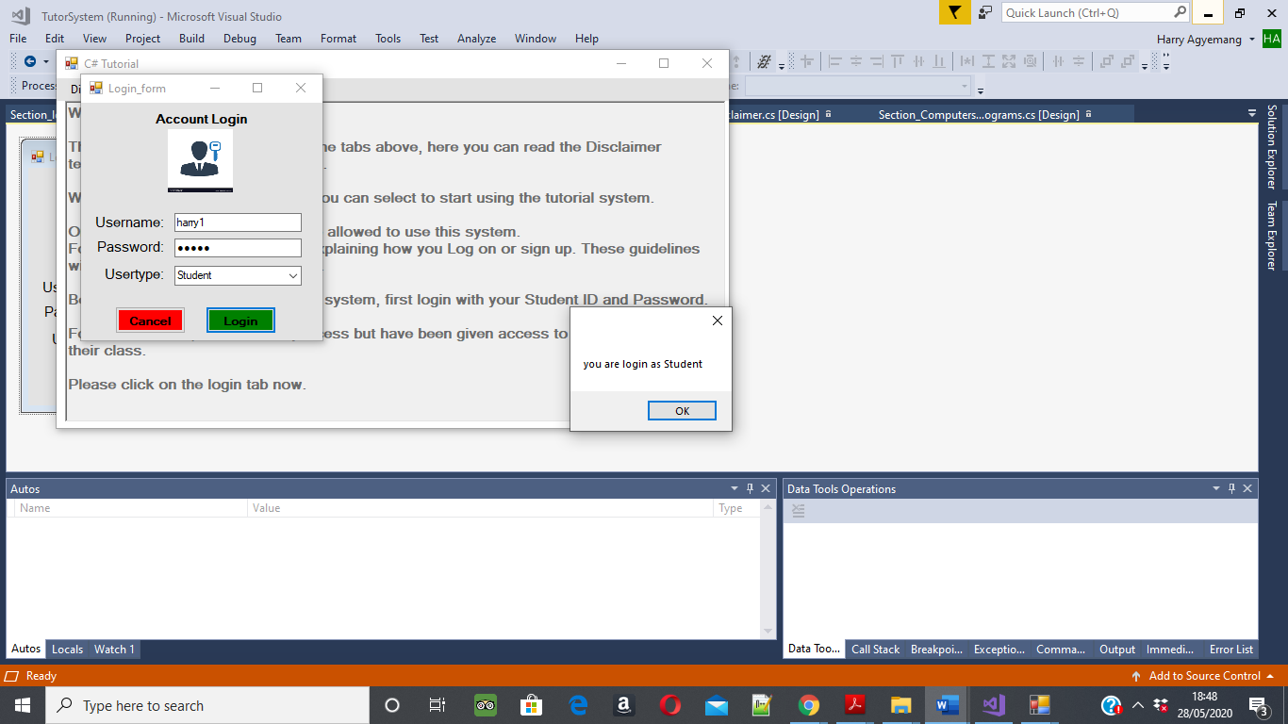

The login screen allows users to do the most common task; it will enable the sign of students.

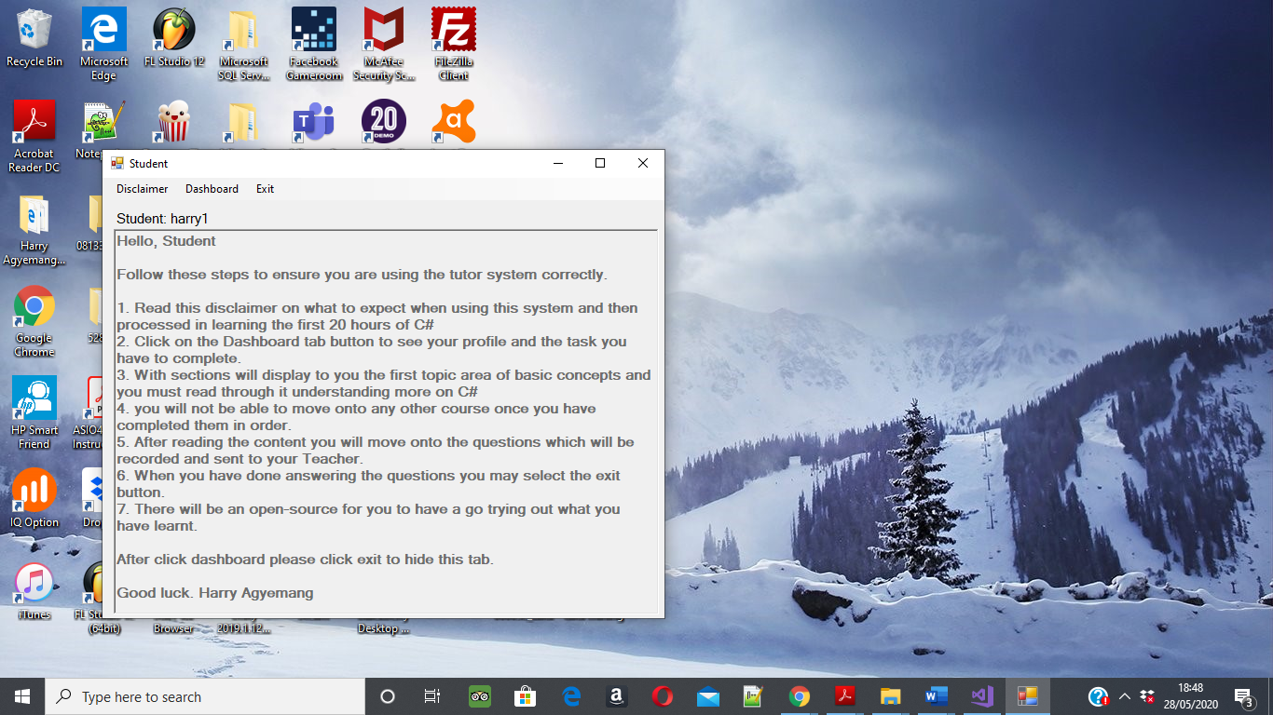

Disclaimer menu for students.

Student view of the dashboard.

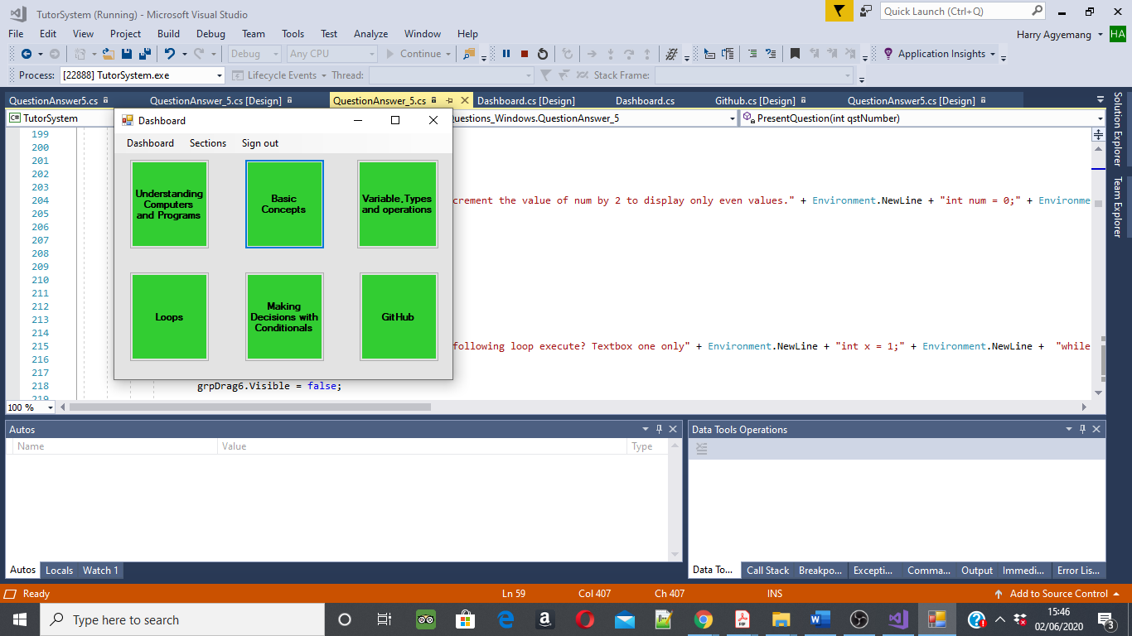

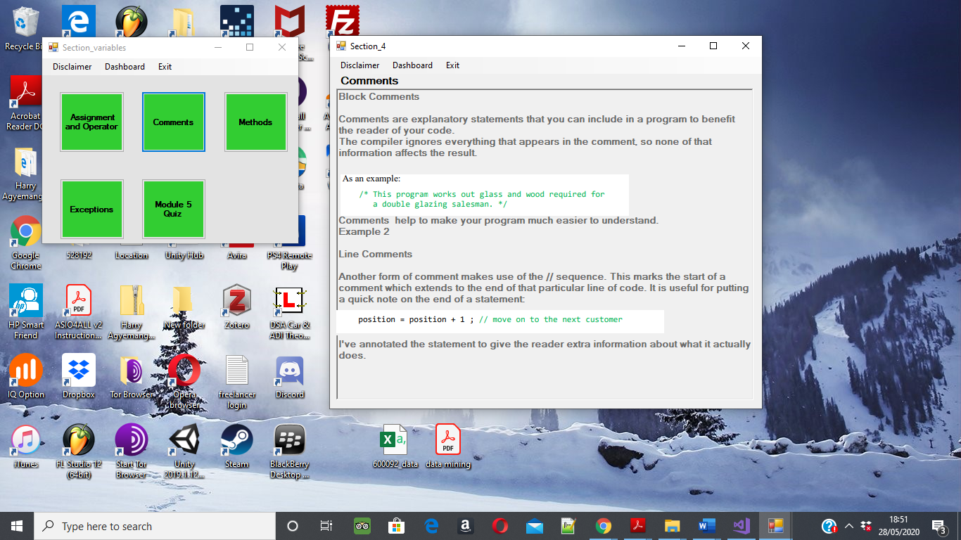

Example of variable section and the subtopic on comments with text and examples

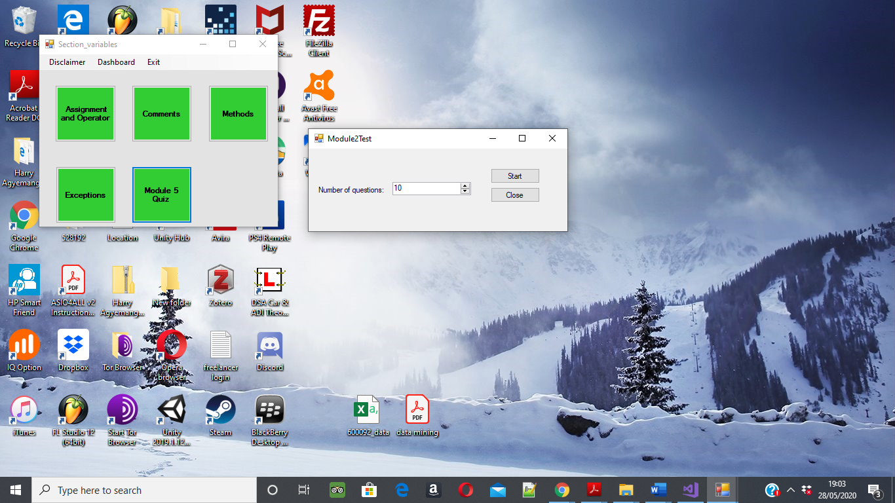

Module quiz starts up box where students can select how many questions they want to do. Recommend they do 10 or 20.

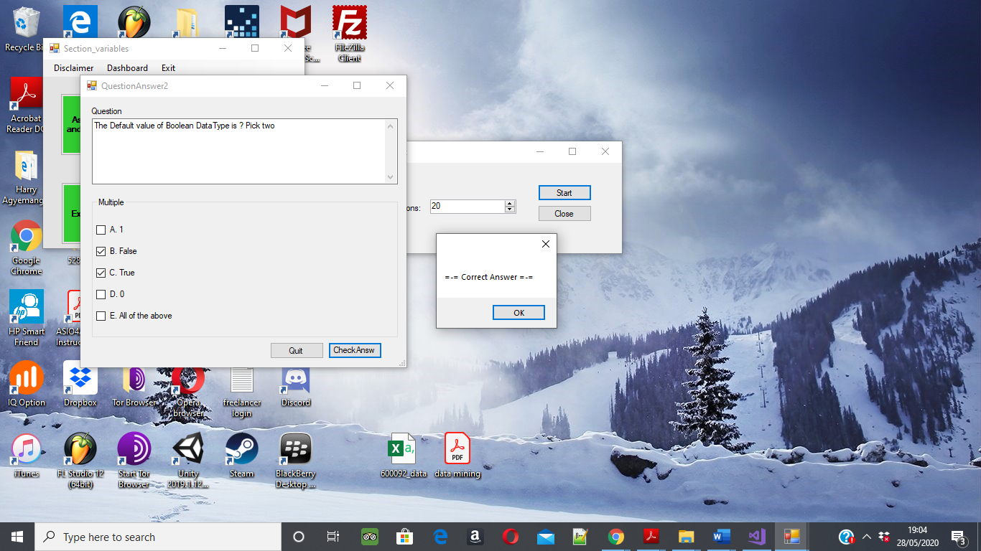

Student using the module quiz and getting the repose of “Correct Answer.”

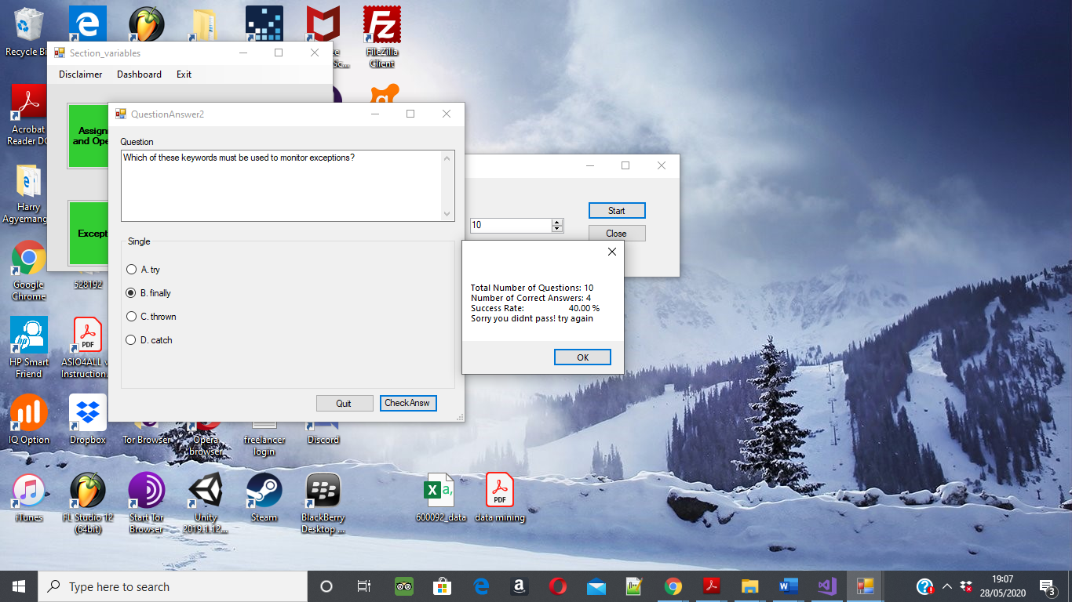

At the end of the module, the quiz will give the user their results.

## Test cases

These were the first product requirements on page 13,14, and this is how we tested them in cases using functional testing.

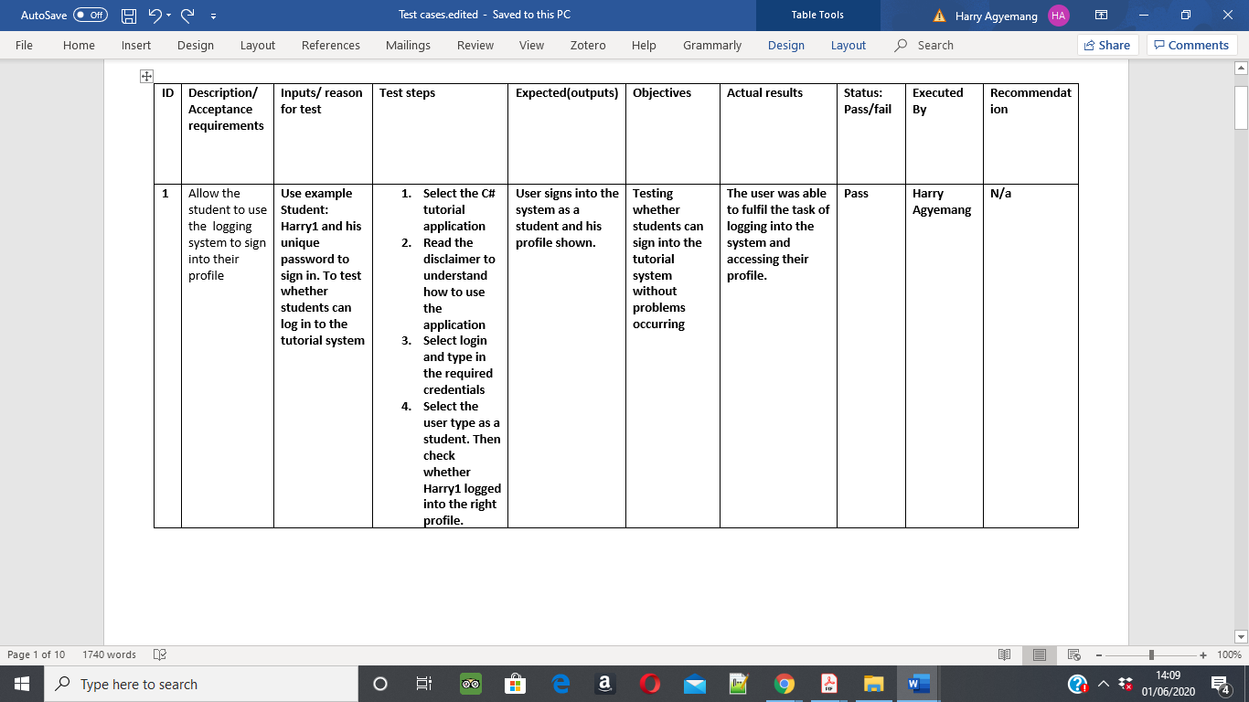

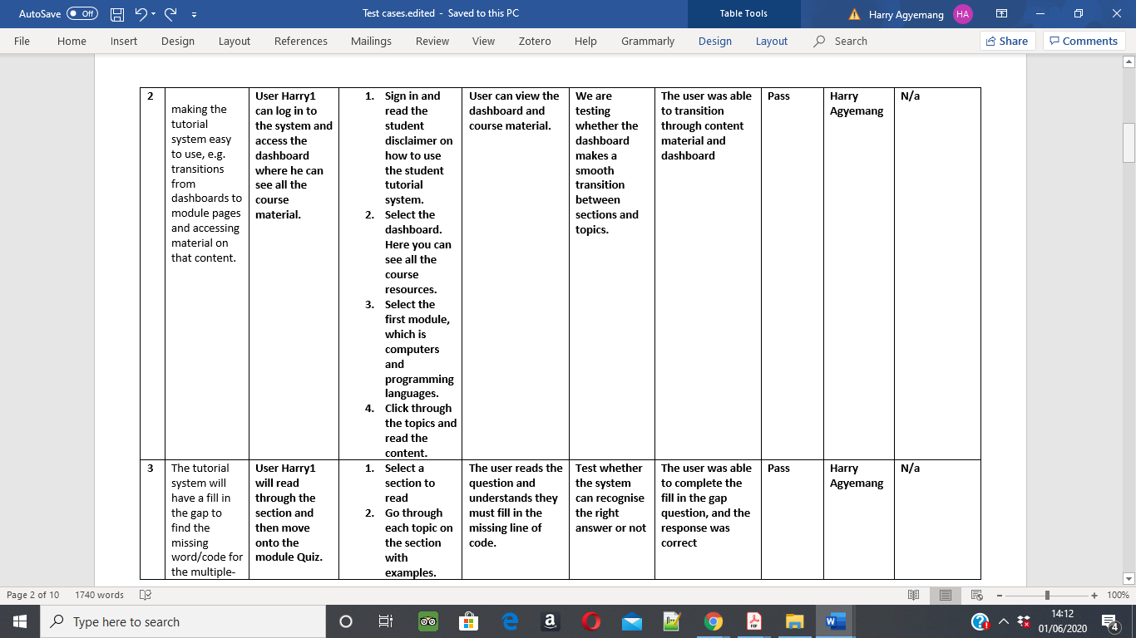

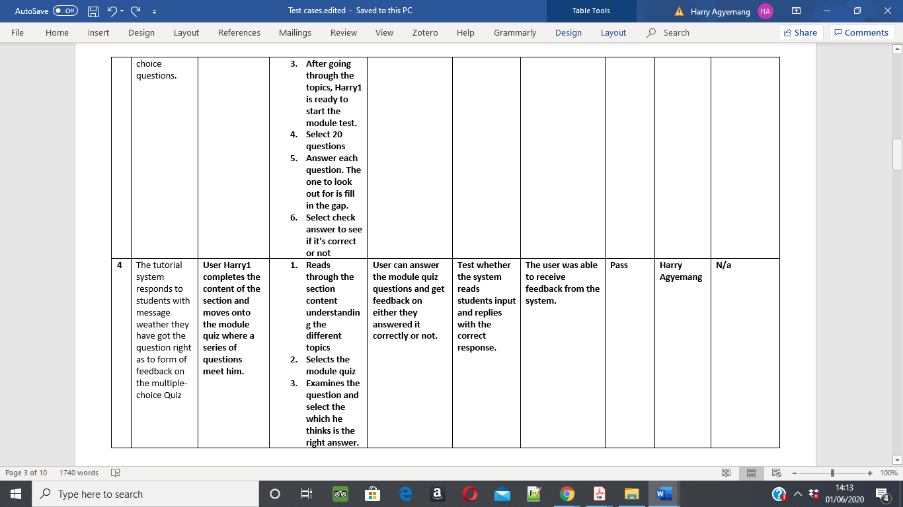

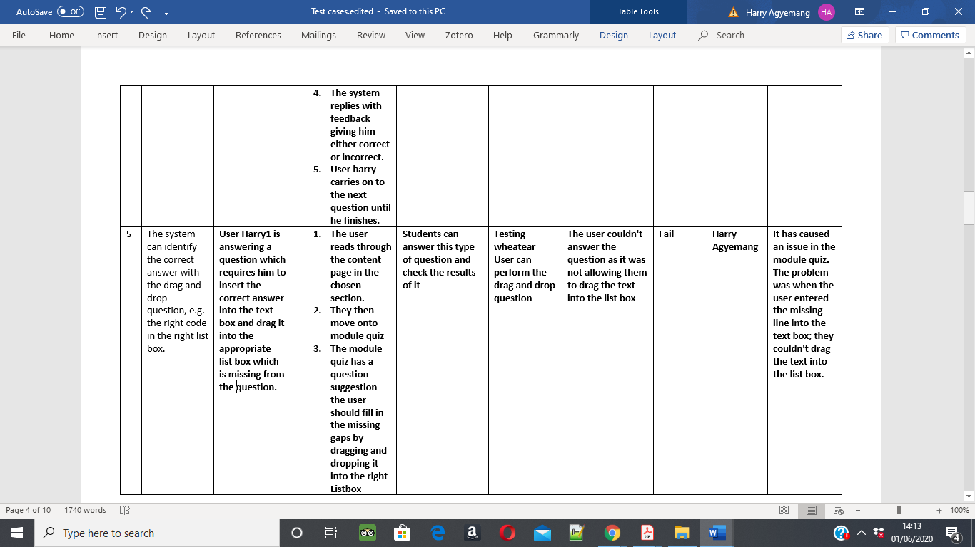

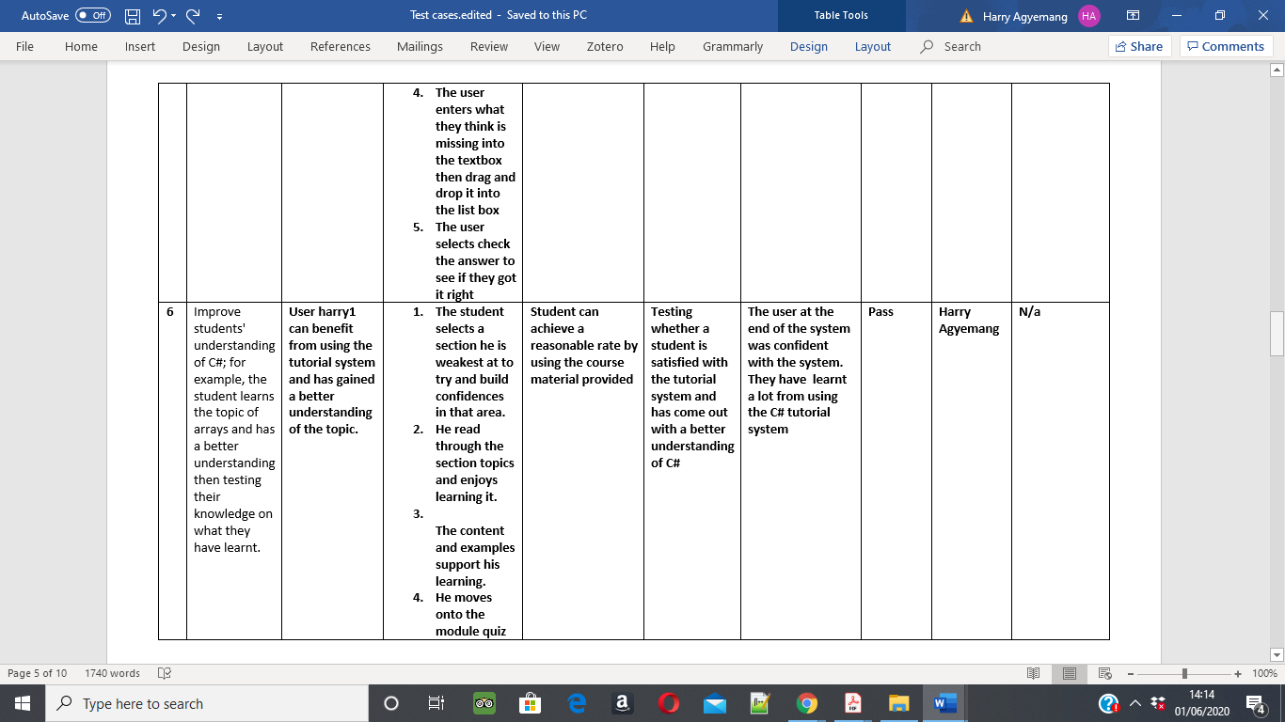

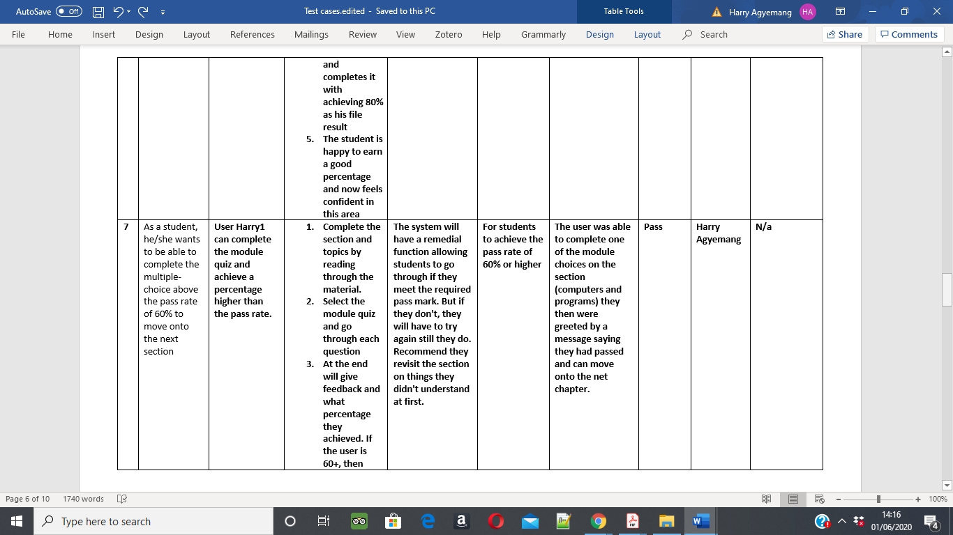

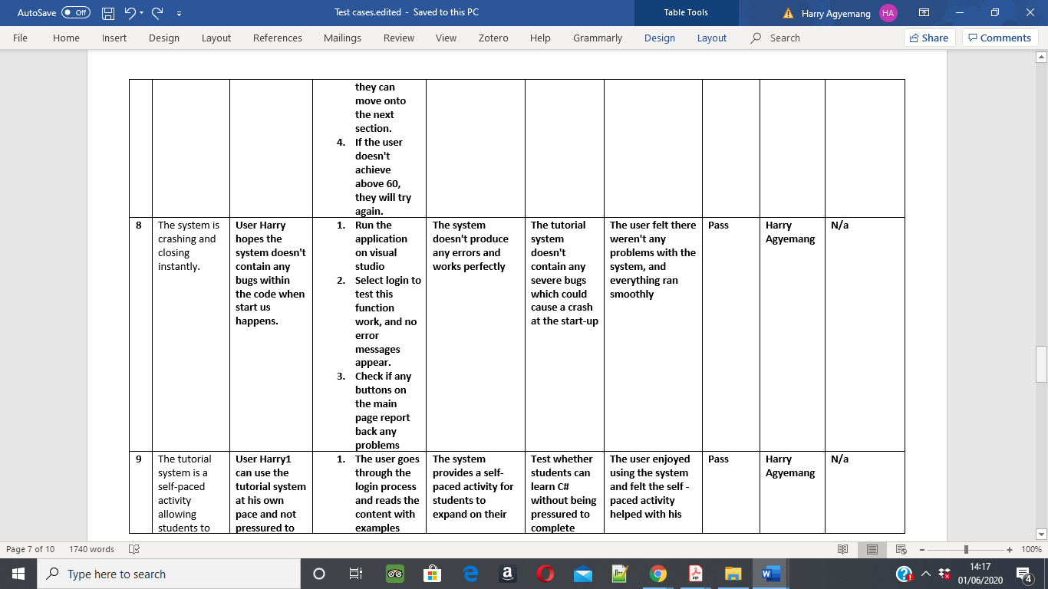

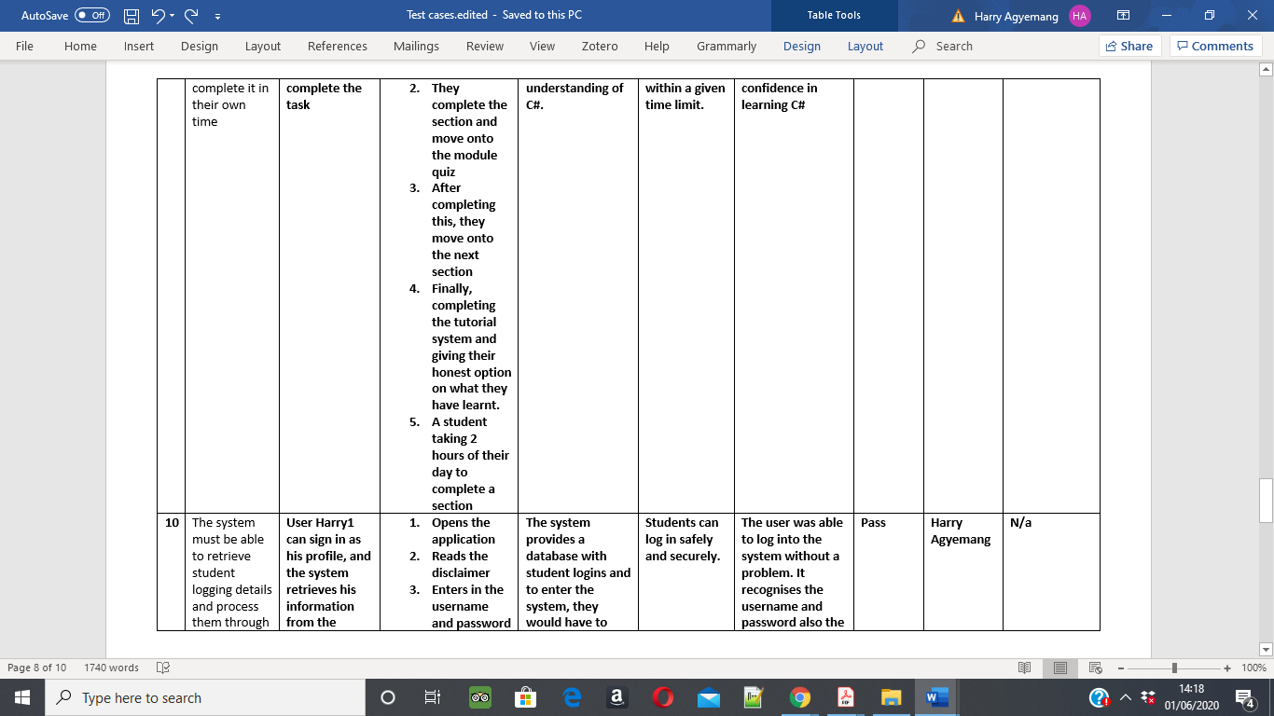

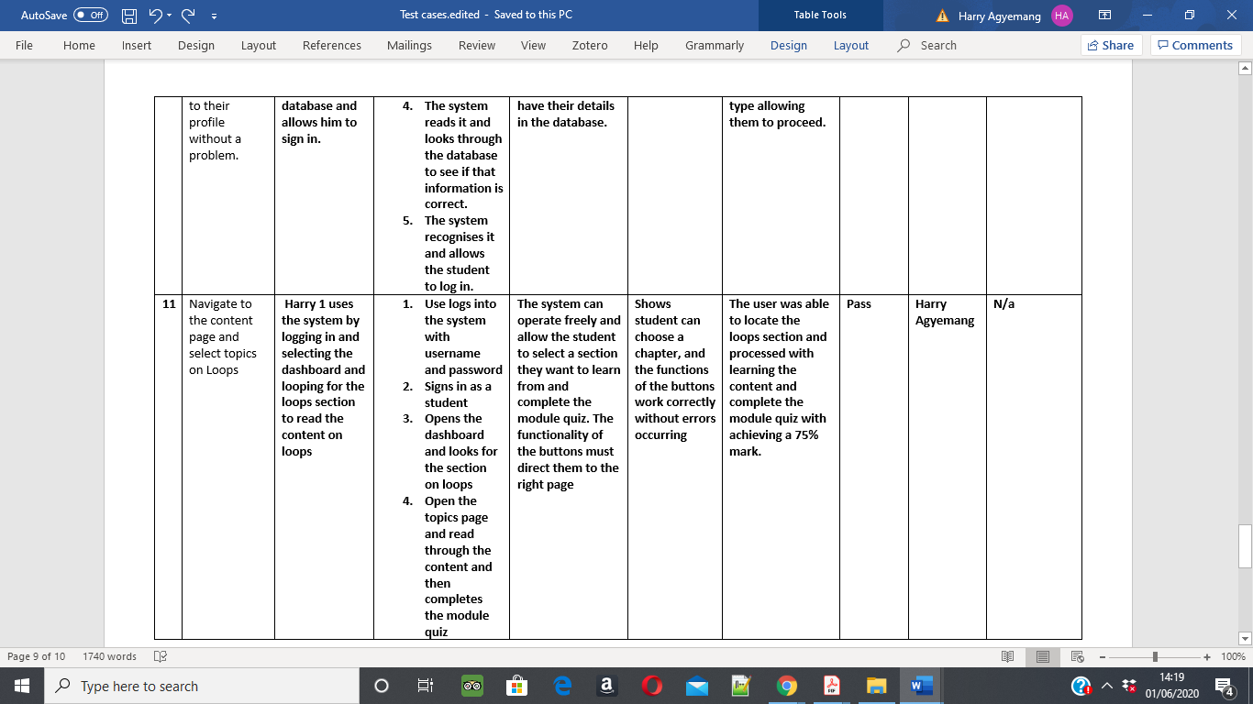

**Conclusion**

After going through the test cases, there is only one problem. These test cases identify the issue and highlight the bugs in the system. After tested the function again and it worked. All the test cases worked fine and are functioning according to their requirement.

# Evaluation

**(a)** A Heuristic Evaluation of the User interface to evaluate it from a user's perspective

For this project, a heuristic evaluation was used to evaluate the system. This Involves having a small set of assessments to examine the interface and give a judgment of its compliances with usability principles. The purpose of this method is to find usability problems in a user interface design, as part of the iterative design process. Different people should find various usability problems within the system. It can improve the effectiveness of the method by involving multiple evaluators inspecting the interface.

Heuristic evaluation is used to reach an immediate goal of the system working and performing up to required standards. Using a technique that others have used proves this method is reliable. Heuristic evaluation used for multiple iterations which means it's possible to get more feedback on the system as the project progresses. In this case, one person will be evaluating the tutorial system but is an expert at this. However, due to ethic consideration real participants weren’t used, this resulted in one expert to conducting they evaluation. This was due to the current pandemic whereby everyone is self-isolating, making it difficult to involve others in the evaluation process. Typically, there would be 3-5 evaluators doing this, but due to circumstances, there will be one. In this care, the evaluators will play the role of an observant and fill in the sheet. The evaluator will run the task and score the severity, describe any issues they faced and provide their recommendations on the tutorial system. The evaluation will be on the feature of the system and its functionality. (Nielsen Norman Group, 2019)

This project would have used heuristic evaluation, but due to circumstances, this has made it impossible, so functional testing replaced the original evaluation test. This project uses software engineering techniques, as the project original plan was to test the systems user interface however process has caused a change in the evaluation of the project’s functions instead. The evaluation will be on the features of the system and its functionality using functional testing.

It would have been ideal to use 5-6 experts on evaluating the software, but because of the recent pandemic, it has made it more challenging to do this. As people are working from home, and they wouldn't be able to access the software from their home computer. Originally this was the plan of evaluating the system using Heuristic Evaluation but has been interrupted by lockdown and so cannot continue with this process. If this does go to plan, there will be one HCI expert evaluating the tutorial system.

**(b)** A Software engineering Systems Analysis based on Requirements Based Acceptance Tests

**Acceptance testing**

The acceptance test is a formal description of the behaviour of software; this expressed as an example or scenario from the user perspective. Its goal is to evaluate the system compliance to assess if it's acceptable for delivery. The aim is to automate the execution, for example, testing by software tools. This test has a binary result of whether it passes or fails. If a fail appears, this can help improve the system as it notices faults within the system. The tests detail will come from the functional specification and express the business requirements. One benefit of using this system is decreasing the severity rate of the test functions. Another is providing a better and more complete system for the customer, e.g. software that passes acceptance tests is consider as being at a good standard (Agile Alliance, 2015).

**Method: Blackbox testing**

In this project, this method will find areas within the systems such as incorrect or missing functions, interface errors and behaviour or performance errors. It will be testing either functional or non-functional requirements of the internal structure of the system and selecting test cases based on an analysis of the specification. There will be one tester, that will test the functions of the system providing inputs and verifying the outputs against the test cases expected outcomes. This testing method will discover bugs within the system to be further analysed (Software Testing Fundamentals, 2018).

**Test cases**

Test cases are a set of conditions which the tester will determine if a system test satisfies the requirements and correctly works. This project will use the test case process to help find problems in the designs of the tutorial system and any other requirement issues. These test cases are mainly focused on the end-user perspective to meet their requirements(Software Testing Fundamentals, 2018).

**Type: Functional testing**

This type of testing deals with the functional requirements of the software. Different functions are tested and provide input for comparing the actual output with its expected. The type of functional test used is User acceptance testing. (Softwaretesting, 2011). This document will describe what the user is permitted to do. It contains all functional specifications, which is the base of all the tests to be conducted by the tester. (Softwaretesting, 2016).

Merging both Blackbox and functional testing will be used to test and technically evaluate the system against its requirements. Then the user interface will be tested using heuristic evaluation. The original evaluation couldn't be used due to recent disruptions therefore, it has changed to a technical assessment for the tutorial system.

**User acceptance test**

Testing the software is essential as it helps validate if all business requirements are fulfilled before releasing the software. These test cases can help fix defects before release, so writing appropriate requirements related to the software and covering all aspects is essential for the development of the system.

**Acceptance criteria**

The Acceptance criteria must ensure the end-users gain the experience and learning benefits from the tutorial system. The initial plan is to point out areas within the system evaluated against the requirements. The results will indicate whether to fix the errors or release. The primary purpose is to define the user stories by providing details on functionality that can help understand whether the story works as expected. (Softwaretestinghelp, 2014)

Objectives

- The system performs its intended function of teaching students’ basic concepts of C#

- The system is usable, for the end user’s goal of managing to complete the course sections

Expectation

- Basic concepts have the correct detailed content and provide students with expert knowledge of the topic. Detailing them vital information to be retained by the system and later be tested

- The student is satisfied with the tutorial system and gains experience with C# and GitHub.

Scenario-oriented acceptance criteria

**Example 1**

User story: As a user, the student wants to be able to access their account with a unique username and password through a login system efficiently

Scenario: logging into the tutorial system

Given: the user met by the disclaimer and then directed onto the login page.

When: The user inserts his username and then his password

And: selects whether he is a student or admin, In this case student.

Then: the system enables the student to sign into their profile, providing the information is correct and matches with the database. (AltexSoft, 2019)

# Conclusion

Overall the project has been a significant success. The background research on C# tutorial and cloud computer has supported the results of the project's research question. What went well was the research behind the tutorial system that helped to design this C# tutor. Looking into the existing tutorial helped with the initial design plans as the goal was to show the journey of how it went from sketches implemented on C# Windows forms. Another successful outcome was using the Gantt chart; this identifies milestones within the project to be successful in completing it. Project control is a constant review against benchmarks.

In this project, there has been a valuable a lesson learnt. These lessons have reflected in the C# tutorial system. The early software development started with the sketches then moving these onto designing and implementing on C# Windows form. It has led to the investigation of the C# tutorial system and cloud computing using GitHub and how to develop a conventional tutorial system while teaching C#. The evaluation used in the C# tutorial has led to dramatic changes in improving the system and making it more user friendly. The evolution has removed errors from the system as they were noted down and fixed. The tutorial system proves students with a better-guided environment can teach students programming which is essential , future works on this can help develop the system into a virtual learning environment.

As research continued and deepened, it led to a freer system which uses advice to guide students through the tutorial. The evaluation used in the tutorial led to significant updates. It proved that a higher degree of guidance and the importance of being transparent, precise and consistent throughout the tutorial are vital for understanding and navigation of students.

On reflection, it's clear to say the system has a correct balance between giving student freedom to explore the structure and restriction in place for moving onto the next section, ensuring students achieve the required pass rate to move on. In the future, this system will be freer and allow the students to follow a variety of paths they choose. Restricting students can only limit them, but allowing them to learn freely can widen their knowledge. For example, in the second prototype, it allows the student to explore five different sections with no restrictions. This proves to be the best solution as students can navigate around the tutorial system without restrictions and access the C# material with ease.

**C# tutorial system**

The prototype displays the benefits of giving iterations and gaining feedback for it. The C# tutorial implements the most efficient teaching method and learning philosophy for the benefit of the student. It caters for all abilities, and each section doesn't contain a difficulty level as it ensures that it meets all students needs making it able to teach students who don't have no knowledge on the subject to students with existing knowledge . At the end of the tutorial system students can test themselves through a series of questions through programming exercises to try to give them a scenario and find solutions.

The C# tutorial system is carried out in the .Net Visual Studio environment, with this student learn within the environment which they may use in the future. The tutorial system allows students to log in with unique logging details for their own experience. One feature removed is the teaching profile; they would be allowed to track and monitor the progress of students. The teaching profile would get updates on questions answered, and each students results from the quiz, would be recorded for teaching purposes. From there, teachers would be able to see what areas a student has weaknesses in and provide where necessary. The teacher profile was also able to add new students, delete and change student passwords. The tutorial system can have the capabilities of a Learning management system.

During this project, there has been a discovery that modern computing is going towards these new ways of software engineering. Teaching students the required skills of version control are essential in their development into the industry.

One improvement for the future would be the feedback mechanism used to explain to the student why the question they got wrong is incorrect. It gives them a much deeper understanding of what they got wrong and explains in a couple of sentences their misconception in that area. Learning from what they have done wrong and knowing the right answer has replaces any previous conception. This system gives the student more of a feel-good factor for their development as they now know the correct answer, and it will stick with them through their learning process.

With the project, the same process of drawing user interface through a series of sketches to show each screen. If this project was repeated done again using a different content or to create software, then this process would still be used. Additionally, prototyping and iteration would be used again as it helped with the development of the software. For example, different iterations of the tutorial system have been evaluated and given feedback on areas it can improve on.

On the other hand, if more time was spent on the project, then it could have been improved. For example, it has taken six months to complete the first twenty hours of the course. If there was additional time on the project happened, then the following hours needed to complete the course would help finish the C# tutorial. Learning the first twenty hours would have given the student confidence and the ability to complete the rest of the course knowing the fundamentals of the module.

The project has improved the subject knowledge for those involved in this project . A basic understanding of C# has increased due to research into the programming language. In the future, there may be a further research and similar project in this area. While research can allow for new information to be found and knowledge to be gained. Additionally, Organisational skills improved during this process as time managing and setting goals was essential.

**Future work**

In the future this tutorial system can develop into having a standard data structure where content from a different course can to be substituted, which will teach students different programming languages such as C++ or Python. All the dialogue can be changed and adapted to the content making it more versatile in terms of teaching courses and extending the tutorial system to teach the entire course. But overall, the engine will still work and continue to perform.

XML also can be used to create the tutorial system. This is a generic mark-up language to indicate with bits of text is teaching and the Questions for a quiz. If created, then the tutorial system would be a virtual learning environment which can work with any system.

Another suggestion for future work with the tutorial system is making the system into a generic tool that can be generalised to other domains. This means each class or object can be moved to another domain and still have the same learning objectives, but for the second domain, and they can learn more. An example of this a virtual learning environment such as Canvas. On this is a series of set forms, it has an engine for creating quizzes. The same engine which issue for all years for the class test with the same generic type facilities on how you can ask questions. An effective way of asking two types of generic questions, is fill in the gap or multiple choice. For example, the old systems would allow you to number the various choices, to be written in a file and then with the multiple choices would put a star on the answer, which is correct.

A virtual learning environment is a designed area for teaching and learning. VLE is a collection of software tools used to help support the teaching and learning of students. It offers a streamlined place where diverse activities for students and teachers can be managed and can help with the administration and organisation of the class. VLE creates a self-learning experience for students. It is becoming familiar with e-learning and is changing education, and the way subjects are taught. For example, teachers move the assessment, feedback, planning lessons, sharing resources and monitor progress to a VLE system. Students can have their assessments returned instantly after an exam. Students have easy access to assignments as well as working at their own pace outside the classroom (Firefly, n.d.)

For the future, everyone is looking to utilise online material as people are staying at home and wanting to work virtually. Online working is moving fast, and with the recent health concerns caused by COVID-19, remote working and online platforms are going to be utilise and necessary for the foreseeable future.

# References

Agile Alliance. (2015). What is Acceptance Testing? [online] Available at:<https://www.agilealliance.org/glossary/acceptance/#q=~(infinite~false~filters~(postType~(~>.

Al-Bastami, B, and Ab-Naser, S.S.  (2017) Design and Development of an Intelligent Tutoring System for C# Language Design and Development of an Intelligent Tutoring System for C# Language, European Academic Research 4(10):8795 8809.  <https://www.researchgate.net/publication/314229313_Design_and_Development_of_an_Intelligent_Tutoring_System_for_C_LanguageDesign_and_Development_of_an_Intelligent_Tutoring_System_for_C_Language> {Accessed 27th April 2020]

AltexSoft. (2019). Acceptance Criteria: Purposes, Formats, and Best Practices. [online] Available at: https://www.altexsoft.com/blog/business/acceptance-criteria-purposes-formats-and-best-practices/ [Accessed 5 Dec. 2019].

Anderson, J.R., Conrad, F. G., Corbett, A.T(1989) . Skill acquisition and the Lisp Tutor. Cognitive Science 13, 467–505.

Anderson, J.R., Corbett, A.T., Koedinger, K.R. and Pelletier, R. (1995). Cognitive Tutors: Lessons Learned. Journal of the Learning Sciences, 4(2), pp.167–207.

Anderson, J.R.( 1983) The architecture of cognition. Cambridge, MA: Harvard University Press.

Apiumhub. (2017). Top 7 benefits you get by using Github | Apiumhub. [online] Available at: https://apiumhub.com/tech-blog-barcelona/using-github/.

Arora, R. (n.d.). Artificial Intelligence: Enhancing the Learning Experience for a Better Future. [online] Available at: https://digitallearning.eletsonline.com/2019/10/artificial-intelligence-enhancing-the-learning-experience-for-a-better-future/ [Accessed 24 Apr. 2020].

Beal, V. (n.d.). What is Cloud-Based? Webopedia Definition. [online] www.webopedia.com. Available at: <https://www.webopedia.com/TERM/C/cloud_based.html>.

Butterfield, A.M., and Brayshaw, M.,  A Pedagogically Motivated Guided Discovery Tutoring System for C#, Proceedings of the HEA STEM (Computing) Learning Technologies 2014 Workshop, University of Hull; 01/2014, <https://www.researchgate.net/publication/263213733_Proceedings_of_the_HEA_STEM_%28Computing%29_Learning_Technologies_2014_Workshop>

Chiu E et al, (2001). Learning C# Tutorial Document, , Available:http://www.devhood.com/training_modules/dist-a/LearningCSharp/learningcsharp.htm (Accessed 1st June 2020)

Corbett, A.T. and Anderson, J.R. (1993). Student Modeling in an Intelligent Programming Tutor. NATO ASI Series, pp.135–144.

Coursera. (2017). Coursera | Online Courses & Credentials by Top Educators. Join for Free. [online] Available at:<https://www.coursera.org/>.

Dāboliņš, J. and Grundspeņķis, J. (2013). The Role of Feedback in Intelligent Tutoring System. Applied Computer Systems, 14(1), pp.88–93.

Dix, A., Findlay, J. Abowd, G., and Beale, R., (2004)  Human Computer Interaction, Pearson: Prentice Hall, 3rd  Edition.

Eisenstadt, M., Brayshaw, M., Hasemer, T. and Issroff, K. (1996) Teaching, Learning and Collaborating at an Open University Virtual Summer School

Firefly. (n.d.). What is a Virtual Learning Environment (VLE)? [online] Available at: https://fireflylearning.com/what-is-a-virtual-learning-environment-vle [Accessed 11 May 2020].

Ghahrai, A. (n.d.). Software Development Methodologies. [online] devqa.io. Available at: https://devqa.io/qa/software-development-methodologies/ [Accessed 11 May 2020].

Git-tower.com. (2013). Why Use Version Control? [online] Available at: https://www.git-tower.com/learn/git/ebook/en/command-line/basics/why-use-version-control.

Gong, Y. (2014). Student Modeling in Intelligent Tutoring Systems. [online] Available at: https://pdfs.semanticscholar.org/ed98/e48494f83f7bd07e33474666b996a9d8ec99.pdf [Accessed 11 Apr. 2020].

Gordon, N., Brayshaw, M. and Grey, S. (2019). A Flexible Approach to Introductory Programming. Proceedings of the 3rd Conference on Computing Education Practice - CEP '19.

Great Schools Partnership, (2013). Learning Experience Definition. [online] The Glossary of Education Reform. Available at:<https://www.edglossary.org/learning-experience/>.

Grey, S. (2014). Using program source control to motivate student learning. Conference: HEA STEM (Computing) Learning Technologies 2014 Workshop At: University of Hull, available at <https://www.researchgate.net/publication/272165372_Using_program_source_control_to_motivate_student_learning?channel=doi&linkId=54dcc2ff0cf28a3d93f86e34&showFulltext=true>( Accessed 27th April,2020

Gross, S., Mokbel, B., Hammer, B. and Pinkwart, N. (2015). Learning Feedback in Intelligent Tutoring Systems. KI - Künstliche Intelligenz, [online] 29(4), pp.413–418. Available at: https://link.springer.com/article/10.1007%2Fs13218-015-0367-y [Accessed 17 Apr. 2020].

Gudivada, V.N. (2016). Cognitive computing : theory and applications. Amsterdam, The Netherlands: North-Holland/Elsevier.

Hall. (2015). Version Control System - Different Models and Software. [online] Available at: https://www.hallme.com/blog/code-version-control/ [Accessed 25 Apr. 2020].

Hasanein, H. and Abu-Naser, S.S. (2017). An intelligent tutoring system for cloud computing. [online] Available at: https://www.researchgate.net/publication/314228965_An_intelligent_tutoring_system_for_cloud_computing [Accessed 11 Apr. 2020].

Important, A. (2014). Why Sketching Is An Important Part of The Design Process. [online] DNN Software. Available at: <https://www.dnnsoftware.com/blog/why-sketching-is-an-important-part-of-the-design-process>.

Jackson, B. (2018). What Is GitHub? A Beginner's Introduction to. [online] Kinsta Managed WordPress Hosting. Available at: <https://kinsta.com/knowledgebase/what-is-github/>.

Johnson, A. (2019). 5 Ways A.I. Is Changing The Education Industry. [online] eLearning Industry. Available at: <https://elearningindustry.com/ai-is-changing-the-education-industry-5-ways>.

Karaolis, S. (2019). [online] 5 brilliant examples of branching in eLearning: branching scenario examples and more. Available at: https://www.elucidat.com/blog/branching-elearning-examples/ [Accessed 5 May 2020].

‌Kumar Pagadala, P. (2015). Intelligent Tutoring System with Virtual Learning Centre and Content Management System with Open Source Tool DRUPAL, Indian Technology Conference 2015 " Intelligent Tutoring System with Virtual Learning Center and Content Management System with Open Source Tool Drupal ", Available at https://www.researchgate.net/publication/318530479_Intelligent_Tutoring_system_with_Virtual_Learning_Center_and_Content_Management_System_with_Open_Source_Tool_Drupal (Accessed 7th April 2020).

Kumon UK, (2020). Kumon maths and English study programmes. [online] Available at: https://www.kumon.co.uk/ [Accessed 17 Apr. 2020].

Lim, J. (n.d.). Glued to Games. www.academia.edu. [online] Available at: https://www.academia.edu/14931342/Glued_to_Games [Accessed 11 Apr. 2020].

Mayo J, (2008), The C# Station Tutorial, , Available: http://www.csharp-station.com/About.aspx , (Accessed, 1st June, 2020)

Miles R,( 2011), Rob Miles C# Yellow Book, Available: http://www.robmiles.com/c-yellow-book/ ((Accessed, 1st January, 2011)

Nielsen Norman Group. (2019). Heuristic Evaluation: How-To: Article by Jakob Nielsen. [online] Available at: https://www.nngroup.com/articles/how-to-conduct-a-heuristic-evaluation/.

Niemiec, C.P. and Ryan, R.M. (2009). Autonomy, competence, and relatedness in the classroom. School Field, 7(2), pp.133–144.

OTC Speckman Tutoring and Learning Center. (n.d.). Mission & Goals. [online] Available at: https://academics.otc.edu/tlc/mission-goals/ [Accessed 17 Apr. 2020].

Polson, M.C. and Richardson, J.J. (2013). Foundations of Intelligent Tutoring Systems. [online] www.taylorfrancis.com. Psychology Press. Available at: <https://www.taylorfrancis.com/books/9780203761557>.

Pressman, R. (2015). Software engineering. 8th ed. New York: McGraw-Hill, p.43.

Pressman, R. (n.d.). Software Engineering A Practitioner’s Approach Seventh Edition. [online] Available at: http://seu1.org/files/level4/IT-242/Software%20Engineering%20_%207th%20Edition.pdf [Accessed 5 May 2020].

Rapids Reproductions. (2017). The Advantages & Disadvantages of Prototyping - Rapids Reproductions. [online] Available at: <https://rapidsrepro.com/advantages-disadvantages-prototyping/>.

Rigby, S., and Ryan, R.M. (2011). Glued to Games: How Video Games Draw Us In and Hold Us Spellbound, Praeger, 2011, ISBN 978-0-313-36224-8

Romero, C., Ventura, S., Pechenizkiy, M. and Baker, R.S.J. d (2010). Handbook of Educational Data Mining. [online] www.taylorfrancis.com. C.R.C. Press. Available at: https://www.taylorfrancis.com/books/e/9780429130120 [Accessed 5 May 2020].

Ryan, R.M., Rigby, C.S. and Przybylski, A. (2011). The Motivational Pull of Video Games: A Self-Determination Theory Approach. Motivation and Emotion, [online] 30(4), pp.344–360. Available at: https://www.academia.edu/24486969/The_Motivational_Pull_of_Video_Games_A_Self-Determination_Theory_Approach [Accessed 11 Apr. 2020].

Sanal, A. (2018). What are Branching Scenarios in E-Learning? [online] E-Learning Gamification, Videos and Courses Development. Available at: https://playxlpro.com/branching-scenarios-in-e-learning/ [Accessed 5 May 2020].

Segue Technologies. (2013). A Review of Software Version Control: Systems, Benefits, and Why it Matters. [online] Available at: https://www.seguetech.com/a-review-of-software-version-control-systems-benefits-and-why-it-matters/.

Selfdeterminationtheory (2014). selfdeterminationtheory– Theory. [online] Available at: https://selfdeterminationtheory.org/theory/.

Shi, L. and Cristea, A. (2016). Motivational Gamification Strategies Rooted in Self- Determination Theory for Social Adaptive E-Learning. Lecture Notes in Computer Science, [online] 9684, pp.294–300. Available at: http://wrap.warwick.ac.uk/78606/1/WRAP_Shi_0582421sl-its2016aic.pdf [Accessed 11 Apr. 2020].

Simplicable. (n.d.). 15 Examples of Product Requirements. [online] Available at: https://simplicable.com/new/product-requirements [Accessed 17 Apr. 2020].

Singh H, 2008, LEARNERSPARADISE.com The learning marketplace, , Available: http://www.learnersparadise.com/mentors/cgi-bin/courseProfile.pl?mentor_id=935 (Accessed 1st June 2020)

Smartsparrow. (2016). What are elements of a great Learning Experience? [online] Available at: https://www.smartsparrow.com/2016/03/04/what-makes-a-learning-experience-great/ [Accessed 6 Nov. 2019].

Smelser, N.J. and Baltes, P.B. (2001). International encyclopedia of the social & behavioural sciences. Amsterdam ; Oxford: Elsevier.

Software House That Helps You Innovate - Neoteric. (2019). A.I. in education: Can A.I. improve the way we teach and learn? - Neoteric. [online] Available at: https://neoteric.eu/blog/ai-in-education-can-ai-improve-the-way-we-teach-and-learn/ [Accessed 24 Apr. 2020].

Software Testing Fundamentals. (2018). Acceptance Testing - Software Testing Fundamentals. [online] Available at:<http://softwaretestingfundamentals.com/acceptance-testing/>.

Software Testing Fundamentals. (2018). Black Box Testing - Software Testing Fundamentals. [online] Available at:<http://softwaretestingfundamentals.com/black-box-testing/>.

Software Testing Fundamentals. (2018). Test Case - Software Testing Fundamentals. [online] Available at:<http://softwaretestingfundamentals.com/test-case/>.

Softwaretestinghelp. (2011). Black Box Testing: An In-depth Tutorial with Examples and Techniques. [online] Available at:<https://www.softwaretestinghelp.com/black-box-testing/>.

Softwaretesting. (2014). What is User Acceptance Testing (UAT): A Complete Guide. [online] Available at:<https://www.softwaretestinghelp.com/what-is-user-acceptance-testing-uat/>.

Softwaretesting. (2016). Functional Testing: A Complete Guide with Types and Example. [online] Available at:<https://www.softwaretestinghelp.com/guide-to-functional-testing/>.

SoloLearn. (n.d.). C# Tutorial. [online] Available at: https://www.sololearn.com/Course/CSharp/ [Accessed 26 Apr. 2020].

Soloway, E. (1986). Learning to program = learning to construct mechanisms and explanations. Communications of the ACM, 29(9), pp.850–858.

Spacey, J. (2016). 9 Types of Design Constraint. [online] Simplicable. Available at:<https://simplicable.com/new/design-constraints>.

Stanford(n.d.). Fully Online | Teaching Commons. [online] Available at: https://teachingcommons.stanford.edu/gallery/fully-online [Accessed 17 Apr. 2020].

Techopedia (2019). What is Human-Computer Interaction (HCI)? - Definition from Techopedia. [online] Available at: <https://www.techopedia.com/definition/3639/human-computer-interaction-hci>.

Thalion (2017). UI Sketching - Why You Should Do This in All Projects | UXMISFIT.COM. [online] Available at: https://uxmisfit.com/2017/11/12/ui-sketching-how-to-make-it-right-and-why-you-should-do-this-in-all-projects/ [Accessed 5 May 2020].

The Understood Team (2019). Remedial Programs: What You Need to Know. [online] Understood.org. Available at:<https://www.understood.org/en/learning-thinking-differences/treatments-approaches/educational-strategies/remedial-programs-what-you-need-to-know>.

Truong, N. (2005). Automated Feedback for "Fill in the Gap" Programming Exercises. [online] pp.117–126. Available at: https://dblp.uni-trier.de/rec/conf/ace/TruongRB05.html [Accessed 17 Apr. 2020].

Westland, J. (2019). 5 Ways To Measure Project Success - ProjectManager.com. [online] ProjectManager.com. Available at: https://www.projectmanager.com/blog/5-ways-to-measure-project-success [Accessed 22 Oct. 2019].

educationbureau. (n.d.). Chapter 3 - Remedial Teaching Strategies. [online] Available at: https://www.edb.gov.hk/en/edu-system/special/resources/serc/irtp/book-3.html#10 [Accessed 5 May 2020].

sciencedirect (n.d.). Intelligent Tutoring System - an overview | ScienceDirect Topics. [online] Available at: https://www.sciencedirect.com/topics/computer-science/intelligent-tutoring-system [Accessed 6 Apr. 2020].

Zolkifli, N.N., Ngah, A. and Deraman, A. (2018). Version Control System: A Review. Procedia Computer Science, 135, pp.408–415.